The intersection of carbon sequestration and habitat provision in built environments: building rating tools comparison
Kamiya Varshney, Maibritt Pedersen Zari and Nilesh Bakshi
Victoria University of Wellington, Wellington, New Zealand
{kamiya.varshney, maibritt.pedersen, nilesh.bakshi}@vuw.ac.nz
Abstract: The expansion of the built environment is a significant driver of climate change and the loss of biodiversity. Subsequently, ecosystem services required for the basic survival of humans are often reduced or removed altogether in many urban contexts. There are numerous building rating tools that are used to conduct building assessments in order to reduce impacts through building design and innovation. This study explores the potential relationships (synergies and trade-offs) between carbon sequestration and habitat provision in building design, and how these can be implemented as an important part of building rating systems. This paper presents a comparative analysis of three building rating tools identifying how they take the provision of habitat and the sequestration of carbon into account during building assessment. Results demonstrate that the building rating systems tend to aim for minimisation of carbon emissions rather than sequestering of carbon from the environment. The only exception to this is the Living Building Challenge. Furthermore, habitat provision is seldom assessed in great detail. The paper concludes by proposing a number of strategies for habitat provision that foster or relate to carbon sequestration in the context of building design.
Keywords: Carbon sequestration; habitat provision; building rating tools; ecosystem services.
1. Introduction
Human interventions have caused approximately 1.0°C of global warming above pre-industrial levels, with a likely range of 0.8°C to 1.2°C. If this continues at the same (or an accelerated) pace, average global warming is likely to reach at least 1.5°C between 2030 and 2052 (IPCC, 2018). Local and regional climates are altered due to urban heat island effects caused by the heat absorption of high mass-built surfaces. Concurrently, greenhouse gas emissions from construction, operation, maintenance, and demolition and some forms of building heating and cooling, significantly affect the functions of ecosystems and biodiversity (Gómez-Baggethun et al., 2013). According to the Intergovernmental Panel on Climate Change (IPCC, 2018), the impacts on biodiversity (including species loss and extinction), are estimated to be lower at 1.5°C of global warming compared to 2°C. Moreover, urbanisation often leads to significant land-use change (though agriculture is still the leading cause of land-use change), which seriously impacts biodiversity, ecological processes, and the quality, quantity, and connectedness of habitats (McDonnell et al., 2008).
Recognising the importance of addressing these issues, over the past three decades (Lee, 2013) sustainable building practices have become more common. An industry-driven response has been the inception and adoption of various building rating tools that aim to optimise building performance and minimise the negative impacts on the environment. Buildings certified by such rating tools are considered to be potentially energy efficient with minimised environmental impact and ones where the physical health conditions of building users may possibly be enhanced (Mattoni et al., 2018). Although neutral or minimal environmental impacts are worthwhile targets for carbon, energy, waste, or water, Pedersen Zari and Jenkin (2009) identify there is significant evidence for the need for net positive, or regenerative ecological, climatic, and human health targets for building design. These can potentially be achieved by concepts such as regenerative design (Pedersen Zari and Jenkin, 2009; Pedersen Zari, 2018). To move towards regenerative design, building rating tools need to assess buildings in a way that encourages design for the provision of ecosystem services (see section 2) aimed at improving ecological health along with human health in both urban and regional contexts (Birkeland, 2012). This potential paradigm shift from negative impact to positive impact, from carbon reduction to carbon sequestration, from vegetation provision for reducing urban heat island effect to habitat provision for multiple species, suggests that the next logical measure would be to establish if, and potentially how current building rating tools can be revised to account for ecosystem services design. To specifically address this line of inquiry this paper focuses on carbon sequestration and habitat provision ecosystem services to better understand the issues and potential of revising current building rating tools.
2. Understanding Ecosystem Services
Today, approximately 55 per cent of the world's population resides in urban areas. By 2050, 68 per cent of the world's population is projected to be urban (United Nation, 2019). With this rise in urban population, urban areas are also expanding. However, humans continue to be dependent on nature (ecosystem services) for survival as well as wellbeing (Gómez-Baggethun et al., 2013). The benefits humans derive from ecosystem functions, either directly or indirectly, are known as ecosystem services (Costanza et al., 1997).
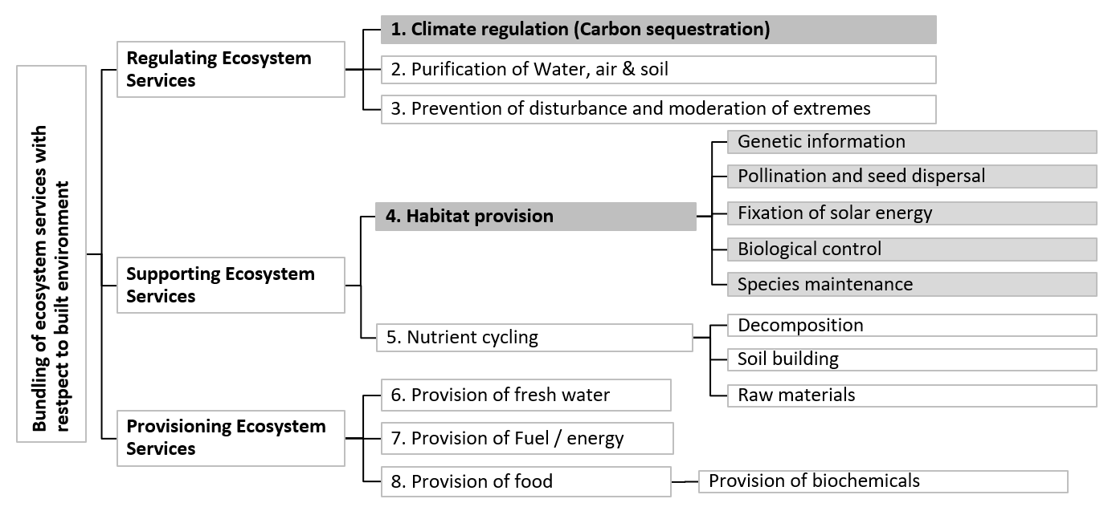
Figure 1: Bundled ecosystem services (modified). Source: (modified from Pedersen Zari, 2018)
According to the Millennium Ecosystem Assessment (MEA, 2005), ecosystem goods and services are the benefits people obtain from ecosystems. In the past three decades, there have been numerous definitions of ecosystem services by policymakers and decision-makers with classifications based on social, economic, and environmental factors. Pedersen Zari (2018) translated ecosystem services thinking into the context of the built environment. That research is the basis of a framework for putting the assessment of ecosystem services into practice in the building industry through inclusion in building rating tools discussed in this paper. Figure 1 outlines the bundled ecosystem services (excluding cultural ecosystem services), adapted and modified from Pedersen Zari (2018). The research scope is limited to two ecosystem services: climate regulation (specifically carbon sequestration) and habitat provision, as shown in Figure 1.
2.1. Climate regulation ecosystem service: carbon sequestration
Climate regulation relates to the regulation of temperature, precipitation, and other biologically mediated climatic processes at global or local levels (Costanza et al., 1997). At a global scale, the emission and sequestration of greenhouse gases are regulated by ecosystems, and at the local scale, land cover and vegetation have an impact on temperature and precipitation (MEA, 2005). Global responses to climate change include mitigation, carbon dioxide removal (CDR), adaptation, and remedial measures (IPCC, 2018). There are many mitigation, adaptation, and remedial strategies which the construction industry have explored or adopted to address climate change through built environment design such as car park minimisation (mitigation), increased use of renewable energy (remedial), and changes to building codes to raise minimum renewable energy requirements or take flooding into account (adaptation) and so on, but little attention is given to carbon dioxide removal from the atmosphere (sequestration) or carbon storage. This paper examines the need for carbon sequestration and storage in the built environment and suggests potential methods to achieve this.
2.2. Habitat provision ecosystem service
Biological ecosystems provide living space for (and are made up of) plant and animal species. The occurrence of most ecosystem functions is due to the species within ecosystems and how they relate to each other, both locally and globally (De Groot et al., 2002). This suggests it is essential to maintain suitable habitat to ensure the provision of ecosystem services, directly or indirectly. Pedersen Zari (2018) described habitat provision in the context of built environment design as comprised of several other ecosystem services. Namely: genetic information; pollination and seed dispersal; fixation of solar energy; biological control; and species maintenance. She bundled them under the umbrella of 'habitat provision' because ecosystem services such as genetic information, pollination, etc. cannot be directly integrated or mimicked by the human built infrastructure itself (Pedersen Zari, 2018) (Figure 1). Therefore, this research also considers 'habitat provision' as the set of bundled ecosystem services.
2.3. The relationship between carbon sequestration and habitat provision
The inter-related issues of climate change and biodiversity loss signal an urgent need to regenerate ecosystems at local, regional, and global scales. Figure 2 illustrates that biodiversity loss due to anthropogenic interventions may be reduced by regeneration of ecosystems and the generation of additional ecosystem services. Moreover, regenerative development may reduce the direct and indirect impacts of climate change through increasing biomass and thus potentially increasing carbon storage and sequestration. Climate change and ecosystem health are inter-related in a positive feedback loop, as illustrated in Figure 2 (Pedersen Zari, 2018). Also, the strategies to address carbon sequestration and habitat provision in the built environment often overlap, mostly because they are both typically reliant on increasing the amount of vegetation in the built environment. So, it is obvious that these two aspects of ecosystem functioning should be addressed together for a maximum strategic benefit to both ecosystem services.
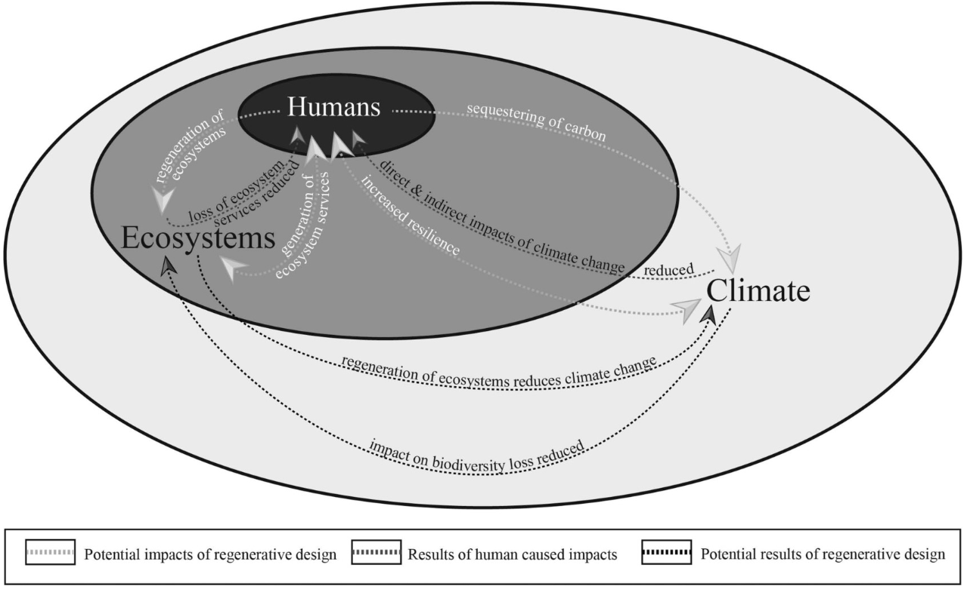
Figure 2: Regenerative design impacts. Source: (Pedersen Zari, 2018, p. 6)
2.3.1. Common strategies for carbon sequestration and habitat provision
Most of the biomass of the stems, branches, roots, and foliage of trees is made up of carbon absorbed from the atmosphere. The main strategy for increasing carbon sequestration in the built environment is to increase vegetation. Similarly, ecological corridors (currently largely fragmented) in the form of domestic gardens, green walls, and green roofs at local and regional scales are potential solutions to conserve biodiversity within urban landscapes (Vergnes et al., 2013). Table 1 lists examples of how designers can commonly apply this strategy of increasing vegetation. Other techniques such as using carbon-based materials in design do exist, but their efficacy is in question (Pedersen Zari, 2019). This is an area of further investigation.
Table 1: Some examples for addressing carbon sequestration and habitat provision concurrently
Examples | Carbon Sequestration | Habitat provision | References
Green roof |  |  | (Hui and Chan, 2011)
Green walls |  |  | (Renger et al., 2015)
Internal courtyards/ atriums |  |  | (Renger et al., 2015)
In-ground landscaping |  |  | (Renger et al., 2015; Shafique et al., 2020)
Wetlands |  |  | (Dymond, 2013)
Agroforestry |  |  | (Pandey, 2002)
2.3.2. Synergies and trade-offs between carbon sequestration and habitat provision
It is important to analyse the contribution of carbon sequestration and habitat provision ecosystem services in the built environment by focusing on the synergies and trade-offs between them. Trade-offs are extremely important to identify so that increasing one ecosystem service does not inadvertently reduce another (Pedersen Zari, 2018). This holistic approach towards regenerative development facilitates ecological and human health and wellbeing. This is elaborated on further with an example of green roofs as a common strategy for carbon sequestration and habitat provision.
Hui and Chan (2011) have developed a systematic method for assessing the biodiversity effects of green roofs through six major factors: (a) species diversity and richness, (b) substrate type and depth, (c) plant species selection, (d) connectivity to natural environment, (e) green roof ratio, and (f) ecologically responsible development. Similarly, Shafique et al. (2020) have provided carbon sequestration assessment of green roofs and suggest that carbon sequestration performance varies with the type of green roof (either extensive or intensive), the plantation type, the green roof coverage (soft v/s hard landscape, blue-green roof), the density of vegetation leaves, composition of the substrate and so on. It is challenging to generalise the role of carbon sequestration and habitat provision in relation to different sustainable strategies adopted. This means that a pragmatic approach is required to know the potential relationships between these two ecosystem services in built environments.
It is important to select species in terms of carbon sequestration, but also for providing habitat. For example, although pinus radiata (a fast-growing exotic pine species to New Zealand) sequesters carbon faster than New Zealand natives initially (when planted in New Zealand), pine forests are not as good as native ones in terms of biodiversity outcomes. Thus, planting pine trees for carbon sequestration would act as a trade-off for habitat provision. Also, it is important to select substrate depth strategically when considering urban vegetation. In the case of green roofs, intensive green roofs sequester more carbon compared to extensive green roofs (Shafique et al., 2020) while intensive green roofs are often better for species diversity and richness (Hui and Chan, 2011). Therefore, the greater the depth of soil, the better it is for both carbon sequestration and habitat provision. This means, within different parameters, it could be possible to provide carbon sequestration and habitat provision concurrently. This would be a synergetic relationship.
3. Examination of three building rating systems
3.1. Methodology
The research method employed in this study is comprised of two stages.
Stage 1: matrices related to all ecosystem services listed in Figure 3 were produced. Different aspects of each building rating tool and different performance goals for sustainable building methods/strategies were examined in order to understand the extent to which ecosystem services are considered during assessment. The matrices were converted into wheel analysis diagrams. Figure 3 illustrates the findings of the analysis. Furthermore, a table indicating the summary of the scope of this research examining how climate regulation (carbon sequestration) and habitat provision are considered by each building rating tool was included in Figure 3.
Stage 2 identified the integration of carbon sequestration and habitat provision in building rating tools and indicated the need for more research in this area.
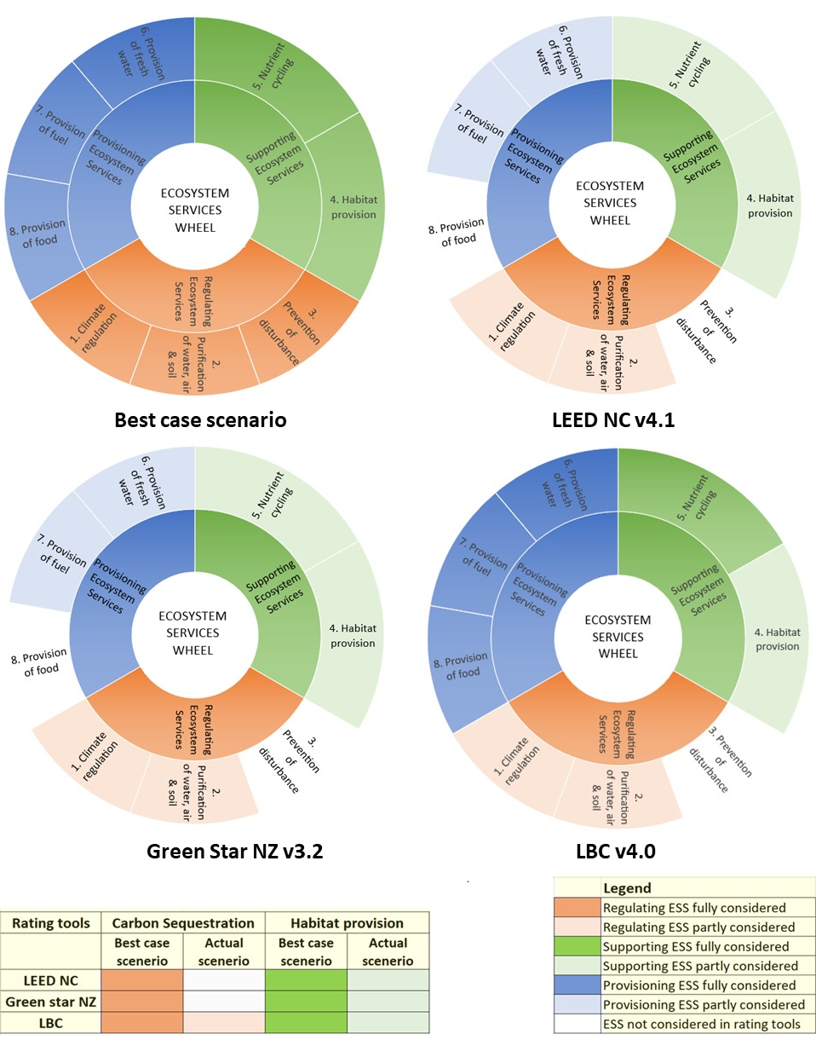
Figure 3: Ecosystem services analysis in building rating tools
3.2. Green building responses
Starting with BREEAM (Building Research Establishment Environmental Assessment) in the United Kingdom, the first rating tool launched in the early 1990s, there has been a significant rise in the number of building rating tools that promote and/or try to measure sustainable development (Lee, 2013). LEED (Leadership in Energy and Environmental Design) from the United States of America (USA), Green Star in Australia, New Zealand, and South Africa, LBC (Living Building Challenge) developed in the USA but used globally, the Evaluation Standard for Green Building (ESGB) from China, CASBEE (Comprehensive Assessment System for Building Environmental Efficiency) from Japan, and IGBC (Indian Green Building Council) from India, along with many more have subsequently emerged as building rating tools for assessment and in some cases design (Lee, 2013). To examine how carbon sequestration and habitat provision are or are not included in existing building rating systems, a comparison has been made with three building rating tools: LEED, Green Star NZ, and LBC. These three building rating tools were selected due to their wide acceptance in India and New Zealand because further research will be situated in these locations.
3.2.1. Leadership in Energy and Environmental Design – New Construction (LEED- NC) v4.1
LEED-NC is divided into eight sections including location and transportation (LT); sustainable sites (SS); water efficiency (WE); energy and atmosphere (EA); materials and resources (MR); indoor environmental quality (EQ); innovation (IN) and; regional priority (RP) (USGBC, 2019). LEED-NC does have a focus on carbon, but the focus is on mitigation of carbon emissions (which is of course important). This is evident from various strategies provided by LEED-NC such as reducing vehicle travel distances through effective planning, consideration of access to public transport and bicycle facilities, reducing car parking footprints, provision of 'green' vehicles, energy optimisation, additional energy savings, and increased use of renewable energy. After analysis of the LEED building rating system, it does not appear to have any aspect that relates specifically to carbon sequestration. This clearly indicates a potential gap in the existing architectural rating system that should be explored.
LEED-NC does have a subsection of site development: protect or restore habitat under the 'Sustainable Sites' category. This urges the importance of "conserving existing natural areas and restoring damaged areas to provide habitat and promote biodiversity" (USGBC, 2019, p. 163). Also, in the sensitive land protection category (under location and transportation) there is a stated aim "to avoid the development of environmentally sensitive lands and reduce the environmental impact from the location of a building on a site" (USGBC, 2019, p. 63). This is to minimise the impact on biodiversity and ecosystem health.
3.2.2. Green Star NZ v3.2 (New Zealand)
Green Star NZ is divided into nine categories, namely: management; indoor environmental quality; energy; transport; water; materials; land use and ecology; emissions; and innovation (Green Star NZ, 2017). These categories have been analysed based on their consideration of carbon sequestration and habitat provision. Green star NZ provides credit for carbon reduction and minimisation of carbon emissions. This is evident from the strategies provided by Green Star NZ (2017) such as greenhouse emission minimisation, car park minimisation, fuel-efficient transport, cyclist facilities, mass commuting transport and travel planning. The Green Star NZ building rating system does not appear to have any aspect that relates specifically to carbon sequestration, however.
In terms of habitat provision, Green Star NZ aims "to encourage and recognise the minimisation of ecological impact from development and encourage ecological enhancement of a site for new and existing buildings" (Green Star NZ, 2017, p. 413). An 'Assessment of Ecological Value' report is prepared before any construction starts and a 'change in ecology calculator' is used to calculate the ecological value before and after construction (Green Star NZ, 2017). Also, wall/roof gardens can be included in the land use and ecology calculator under certain conditions described by Green star NZ in their manual.
3.2.3. Living Building Challenge (LBC) v4.0
The Living Building Challenge (LBC, 2019) is divided into seven categories, namely: place; water; energy health + happiness; materials; equity; and beauty. For this research, 'Living Certification' was analysed because it aims for the highest level of sustainability and regenerative design. Categories of LBC have been analysed based on their consideration of carbon sequestration and habitat provision. LBC not only aims for carbon emission reduction through various strategies such as 'energy + carbon reduction (treating energy as a precious resource)' and 'human-scaled living (effective planning to contribute toward pedestrian-oriented community)' but also aims for 'net positive carbon (through carbon sequestration or carbon offset purchase)' which makes it unique among the typical building rating schemes.
Moreover, LBC has an imperative which directly relates to habitat provision; 'ecology of place', which is intended to preserve thriving vibrant ecological environments and habitats. For this purpose, LBC (2019, p. 30) states that "all project teams must document site and community conditions before the start of work, including but not limited to identification of the project's 'reference habitat(s)' and all projects must demonstrate that they contribute positively to the ecology of their place and restore or enhance the ecological performance of the site towards a healthy ecological baseline". However, LBC 2019 v 4.0 is the modified version released in the year 2019. This section was renamed as 'ecology of place' (earlier 'limits to growth' in v3.1, LBC, 2016). In the previous version 3.1, LBC (2016, p. 24) advised that "projects may only build on greyfields or brownfields: previously developed sites that are not classified as on or adjacent to any of the sensitive ecological habitats such as wetlands, primary dunes, old-growth forest, virgin prairie, prime farmland, or within the 100-year flood plain". LBC 2019 has updated from the restriction on site selection to a performance-based approach in terms of the project location, local ecology, and community. This clearly signals the increasing awareness and ongoing measures to address biodiversity loss.
3.3. Carbon sequestration and habitat provision in the rating tools studied
Section 3.2.1 and 3.2.2 identify both LEED and Green Star NZ can include carbon dioxide removal (CDR) in building assessment. This will potentially enhance the rating tools by considering carbon reduction and removing existing carbon in the atmosphere through carbon sequestration to address global climate change. Habitat provision is included in LEED and Green star NZ; however, the biodiversity assessment is not provided based on the performance of habitat provision (this is further elaborated upon below).
LBC is ahead of most of the building rating tools (which is noticeable from the comparison done in Section 3.2) because it aims to move towards a fully restorative development. As discussed in Section 3.2.3, the LBC includes the category ('petal') of 'net positive carbon' that states "all projects must account for the total embodied carbon emissions (tCO2e) from construction, through the utilization of carbon-sequestering materials…" (LBC, 2019, p. 42) However, carbon sequestration is not limited to 'sequestering materials', it needs to include factors affecting the efficiency of carbon sequestration and the credits should be awarded according to their performance. The effectiveness of carbon sequestration varies in different scenarios, different climates, different building typologies, the density and type of vegetation, LAI (Leaf Area Index); area/coverage of different land types: pristine land/greenfield/brownfield development/coastal area, new build v/s retro-fit, location of the site, selection of plant species, composition of the substrate, etc. Designs must, therefore, be site specific. Credits should not be awarded for following a certain strategy; however, building rating tools should take into account the efficiency of strategy followed, related to a project's specific context. This should be included in LBC, Green star NZ, and LEED.
Habitat provision is defined in LBC as 'all projects must demonstrate that they contribute positively to the ecology of their place and restore or enhance the ecological performance of the site towards a healthy ecological baseline.' However, as pointed out above, the effectiveness of habitat provision strategies for the enhancement of the ecological performance of a specific site should be carefully monitored over time because it depends on various factors such as species diversity and richness, substrate type and depth, plant species selection, connectivity to the natural environment, green roof ratios, ecologically responsible development, building materials used for pavements and ledge walls etc., degree of shading, the presence of microtopography, slopes, the presence of water, and presence of keystone species etc (Lundholm, 2006; Hui and Chan, 2011).
4. Conclusion and scope for future research
Biodiversity loss and climate change are often treated as separate issues; however, they are intimately linked (section 2.4) and must be addressed together, along with an examination of strategies which could help to enhance urban biodiversity and sequester carbon concurrently. Firstly, designers need to understand that buildings should not lead to increased pressure on climate and ecosystems. Secondly, maintaining and enhancing ecosystem health should be considered as equally important as working towards improving human health or aesthetic value (none of which are mutually exclusive).
It is necessary to understand design strategies that enhance or maintain urban biodiversity, and at the same time provide the urban infrastructure that meets appropriate engineering, environmental, and societal criteria within the context of climate change (Gómez-Baggethun et al., 2013). Also, there are emerging strategies in advanced construction and building research aiming to go beyond 'fewer negative' impacts that could potentially result in embodied carbon payback by considering building-integrated carbon sequestration through increasing biomass (Renger et al., 2015). This study is not exhaustive, and there are limitations. However, it provides a good baseline to check whether carbon sequestration and habitat provision are already considered within building rating tools in order to identify the gap in knowledge and potentials for future research directions. This research shows there is scope to study different strategies in detail, which not only enhance biodiversity by providing habitat but also sequester carbon from the atmosphere as a solution to the inter-related issues of climate change and biodiversity loss. Furthermore, this research suggests that there is a need to identify how to combine these strategies or how to plot synergies and trade-offs between different building techniques or technologies to identify optimal solutions through the medium of building design. Future results will provide guidelines to designers and architects which can be used to concurrently design for building integrated carbon sequestration and habitat provision with minimal trade-offs.
References
Birkeland, J. (2012) Positive development: from vicious circles to virtuous cycles through built environment design, ed., Routledge.
Costanza, R., d'Arge, R., De Groot, R., Farber, S., Grasso, M., Hannon, B., Limburg, K., Naeem, S., O'neill, R. V. and Paruelo, J. (1997) The value of the world's ecosystem services and natural capital, nature, 387(6630), 253-260.
De Groot, R. S., Wilson, M. A. and Boumans, R. M. (2002) A typology for the classification, description and valuation of ecosystem functions, goods and services, Ecological economics, 41(3), 393-408.
Dymond, J. R. (2013) Ecosystem services in New Zealand: conditions and trends, ed., Manaaki Whenua Press, Landcare Research.
Gómez-Baggethun, E., Gren, Å., Barton, D. N., Langemeyer, J., McPhearson, T., O'Farrell, P., Andersson, E., Hamstead, Z. and Kremer, P. (2013) Urban ecosystem services, in, Urbanization, biodiversity and ecosystem services: Challenges and opportunities, Springer, Dordrecht, 175-251.
Green Star NZ (2017) Green Star Technical Manual v3.2.
Hui, S. C. and Chan, K. (2011) Biodiversity assessment of green roofs for green building design, Proceedings of Joint Symposium 2011 on Integrated Building Design in the New Era of Sustainability.
IPCC (2018) Global Warming of 1.5 C An IPCC Special Report on the Impacts of Global Warming of 1.5 C Above Pre-Industrial Levels and Related Global Greenhouse Gas Emission Pathways, in the Context of Strengthening the Global Response to the Threat of Climate Change, Sustainable Development, and Efforts to Eradicate Poverty
LBC (2016) LIVING BUILDING CHALLENGE v3.1.
LBC (2019) LIVING BUILDING CHALLENGE v4.0.
Lee, W. (2013) A comprehensive review of metrics of building environmental assessment schemes, Energy and Buildings, 62, 403-413.
Lundholm, J. T. (2006) Green roofs and facades: a habitat template approach, Urban habitats, 4(1), 87-101.
Mattoni, B., Guattari, C., Evangelisti, L., Bisegna, F., Gori, P. and Asdrubali, F. (2018) Critical review and methodological approach to evaluate the differences among international green building rating tools, Renewable and Sustainable Energy Reviews, 82(P1), 950-960.
McDonnell, M. J., Pickett, S. T., Groffman, P., Bohlen, P., Pouyat, R. V., Zipperer, W. C., Parmelee, R. W., Carreiro, M. M. and Medley, K. (2008) Ecosystem processes along an urban-to-rural gradient, in, Urban Ecology, Springer, 299-313.
MEA (2005) Ecosystems and human well being, General synthesis, Island Press, Washington DC, USA.
Pandey, D. N. (2002) Carbon sequestration in agroforestry systems, Climate policy, 2(4), 367-377.
Pedersen Zari, M. (2018) Regenerative urban design and ecosystem biomimicry, Routledge research in sustainable urbanism, ed., Routledge, Abingdon, Oxon
Pedersen Zari, M. (2019) Ecosystem services impacts as part of building materials selection criteria, Materials Today Sustainability, 3, 100010.
Pedersen Zari, M. and Jenkin, S. (2009) Re-defining cutting edge sustainable design: from eco-efficiency to regenerative development.
Renger, B. C., Birkeland, J. L. and Midmore, D. J. (2015) Net-positive building carbon sequestration, Building Research and Information, 43(1), 11-24.
Shafique, M., Xue, X. and Luo, X. (2020) An overview of carbon sequestration of green roofs in urban areas, Urban Forestry and Urban Greening, 47, 126515.
United Nation (2019) Department of Economic and Social Affairs, Population Division, World Urbanization Prospects: The 2018 Revision (ST/ESA/SER.A/420).
USGBC (2019) LEED v4. 1 BUILDING DESIGN AND CONSTRUCTION.
Vergnes, A., Kerbiriou, C. and Clergeau, P. (2013) Ecological corridors also operate in an urban matrix: a test case with garden shrews, Urban Ecosystems, 16(3), 511-525.
There is a section break below, please do not delete it.

There is a section break above, please do not delete it.

