Heterotopia: After the Fall

First Author
Daniel K. Brown (MArch, Yale University)
Reader in Design Studio, Associate Dean (Academic Development)
Faculty of Architecture and Design, Victoria University of Wellington
139 Vivian Street
Wellington, New Zealand 6011
+644 463 6129
daniel.brown@vuw.a.nz

Second Author
William A. Duncan
MArch (Prof) Candidate
School of Architecture, Victoria University of Wellington
139 Vivian Street
Wellington, New Zealand 6011
+6421 0296 3754
willie.duncan007@gmail.com

Abstract
In January 2016 Angela Merkel announced that Syrian war refugees in Europe would be repatriated once the Syrian war is over. But for many Syrians, their ancestral homes have been destroyed. This investigation looks at how architecture can be used to help repatriate post-war refugees back into war ravaged cities – by providing new architecture that can be recognised as ‘home’, while also acting as a memorial to a tragic disaster and establishing itself as a symbol of hope. The city of Bosra-al Sham in Syria represents the design research site. In Bosra there has been a significant loss not only of thousands of buildings and lives during the Syrian war, but also wanton destruction of ancient architecture that symbolises its cultural heritage. This project looks at speculative ways to strategically implicate both the damaged contemporary and the damaged historic ruins into the design of a new ‘home’ for refugees returning to Bosra.
The research proposition is grounded in Michel Foucault’s theory of ‘heterotopias’: re-conceiving architecture as ‘counter-site’, inverting and contesting what would be traditionally considered ‘real place’. The research argues that by understanding war-torn Bosra as a heterotopia, architecture can help returning refugees straddle the fine line that separates utopia from dystopia. The research integrates Foucault’s critique of heterotopias with theories by Penelope Haralambidou relating to allegory and architecture. Haralambidou argues that allegory can play a significant role in directly engaging strategic visions for society – not only through architecture as built work, but also through speculative architecture conceived specifically as drawing and model.
Keywords
heterotopia, counter-site, memorial, ruin, temporality

Preface

This paper looks at how architecture can help repatriate returning Syrian refugees, when their homes and cities have been devastated by war. As a New Zealand architect, my experience of the devastation of war is non-existent. I cannot possibly comprehend the tragedy that has resulted from the war in Syria.

But in my own lifetime, I have experienced one formidable calamity: a magnitude 7.1 earthquake struck Christchurch, New Zealand on the 4th of September 2010, followed just six months later by a magnitude 6.3 earthquake on the 22nd of February 2011. The second quake lasted only ten seconds. But its shallow epicentre near the centre of the city – combined with Christchurch’s already weakened infrastructure from the first major quake – resulted in one of the deadliest disasters to ever strike New Zealand.
Figure 1. Christchurch, NZ 2011 | Figure 2. Christchurch, NZ 2012
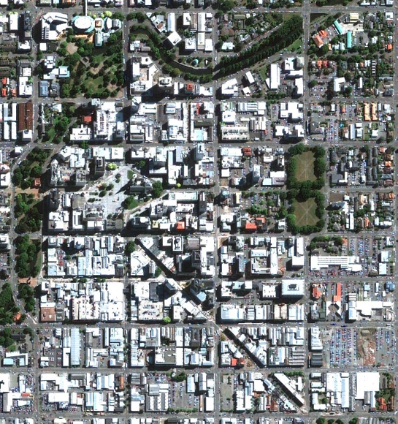 | 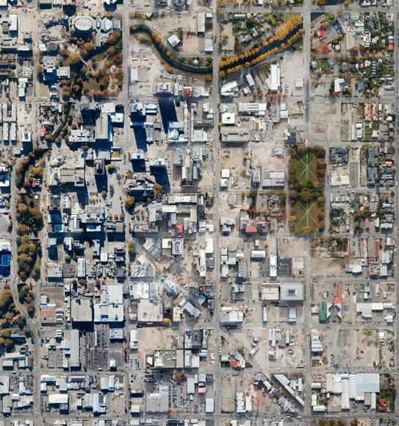
Source: Google Earth | Source: Google Earth
Figure 1 shows an aerial view of Christchurch as it appeared just before the 2011 earthquake. Figure 2 shows the same view after the quake. While the loss of lives was devastating on a deeply personal level, I was also struck by the loss of a city’s cultural memory. Christchurch had lost her most iconic heritage architecture (Figure 3); and the citizens of Christchurch had lost their homes (Figure 4). The earthquake-damaged buildings were eventually torn down – all traces removed. And even today, most of the citizens have not returned to live in the historic city centre.
Figure 3. Christchurch Cathedral | Figure 4. Private House, Christchurch
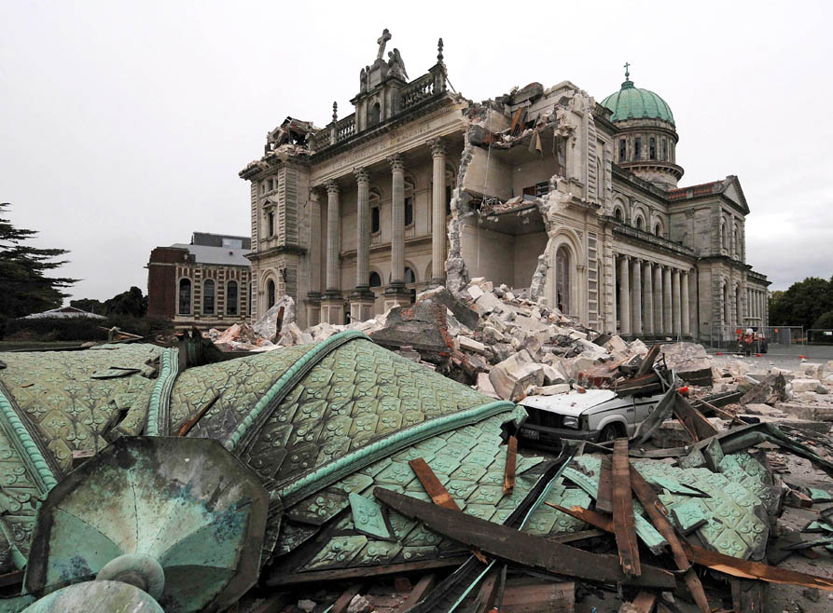 | 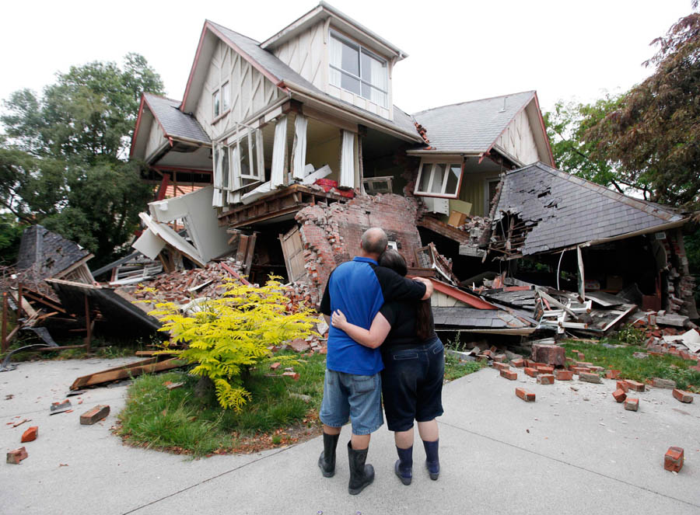
Source: David Wethey / AP Photo | Source: Mark Baker / AP Photo

As a New Zealand architect, I asked myself: what happens when people return to a place defined by destruction and loss of the architecture that once reflected their cultural heritage? Should all the remnants of destruction be permanently removed? Or is there a fundamental reason to retain some remnants of the architectural destruction to help citizens to: retain their memories of ‘home’; understand a devastating event as a significant chapter in their on-going cultural history; and join together as a community again?

Introduction
This paper addresses these questions from the perspective of the returning Syrian refugee. In January 2016 Angela Merkel announced that Syrian refugees in Europe would be repatriated to Syria once the war is over. But for many Syrians, their ancestral homes have been completely destroyed. How can architecture help repatriate post-war Syrian refugees back into cities that have been ravaged by war, cities where their homes no longer exist? How can new architecture provide a new ‘home’ – one that can act as a memorial to a tragic disaster, while also establishing itself as a symbol of hope?
This investigation “Heterotopia: After the Fall” examines the role speculative architecture can play in addressing the repatriation of war refugees, when their cities, homes and cultural artefacts have been lost. The speculative design research site is the ancient Syrian city of Bosra-al Sham. In Bosra there has been a significant loss not only of thousands of buildings and lives during the Syrian war, but also wanton destruction of ancient architecture that symbolises its cultural heritage.
Both the contemporary and the historic ruins should play a strategic role when rebuilding Bosra and repatriating its refugees back into their damaged homeland. Ruins trigger important memories relating to home, community and heritage. If architecture can actively protect ruins, they can be re-activated and understood as facilitators of social memory and reflections of a vital cultural timeline. By positioning new architecture on the threshold between the ruins of the contemporary city of Bosra-al Sham and the ruins of the ancient heritage city (Figure 5), this tragic period can perhaps be better understood by its returning citizens as another significant chapter in an on-going narrative about a culture that refuses to be lost or forgotten. And the road to recovery can be enhanced.
Figure 5. Basra-al Sham, Syria
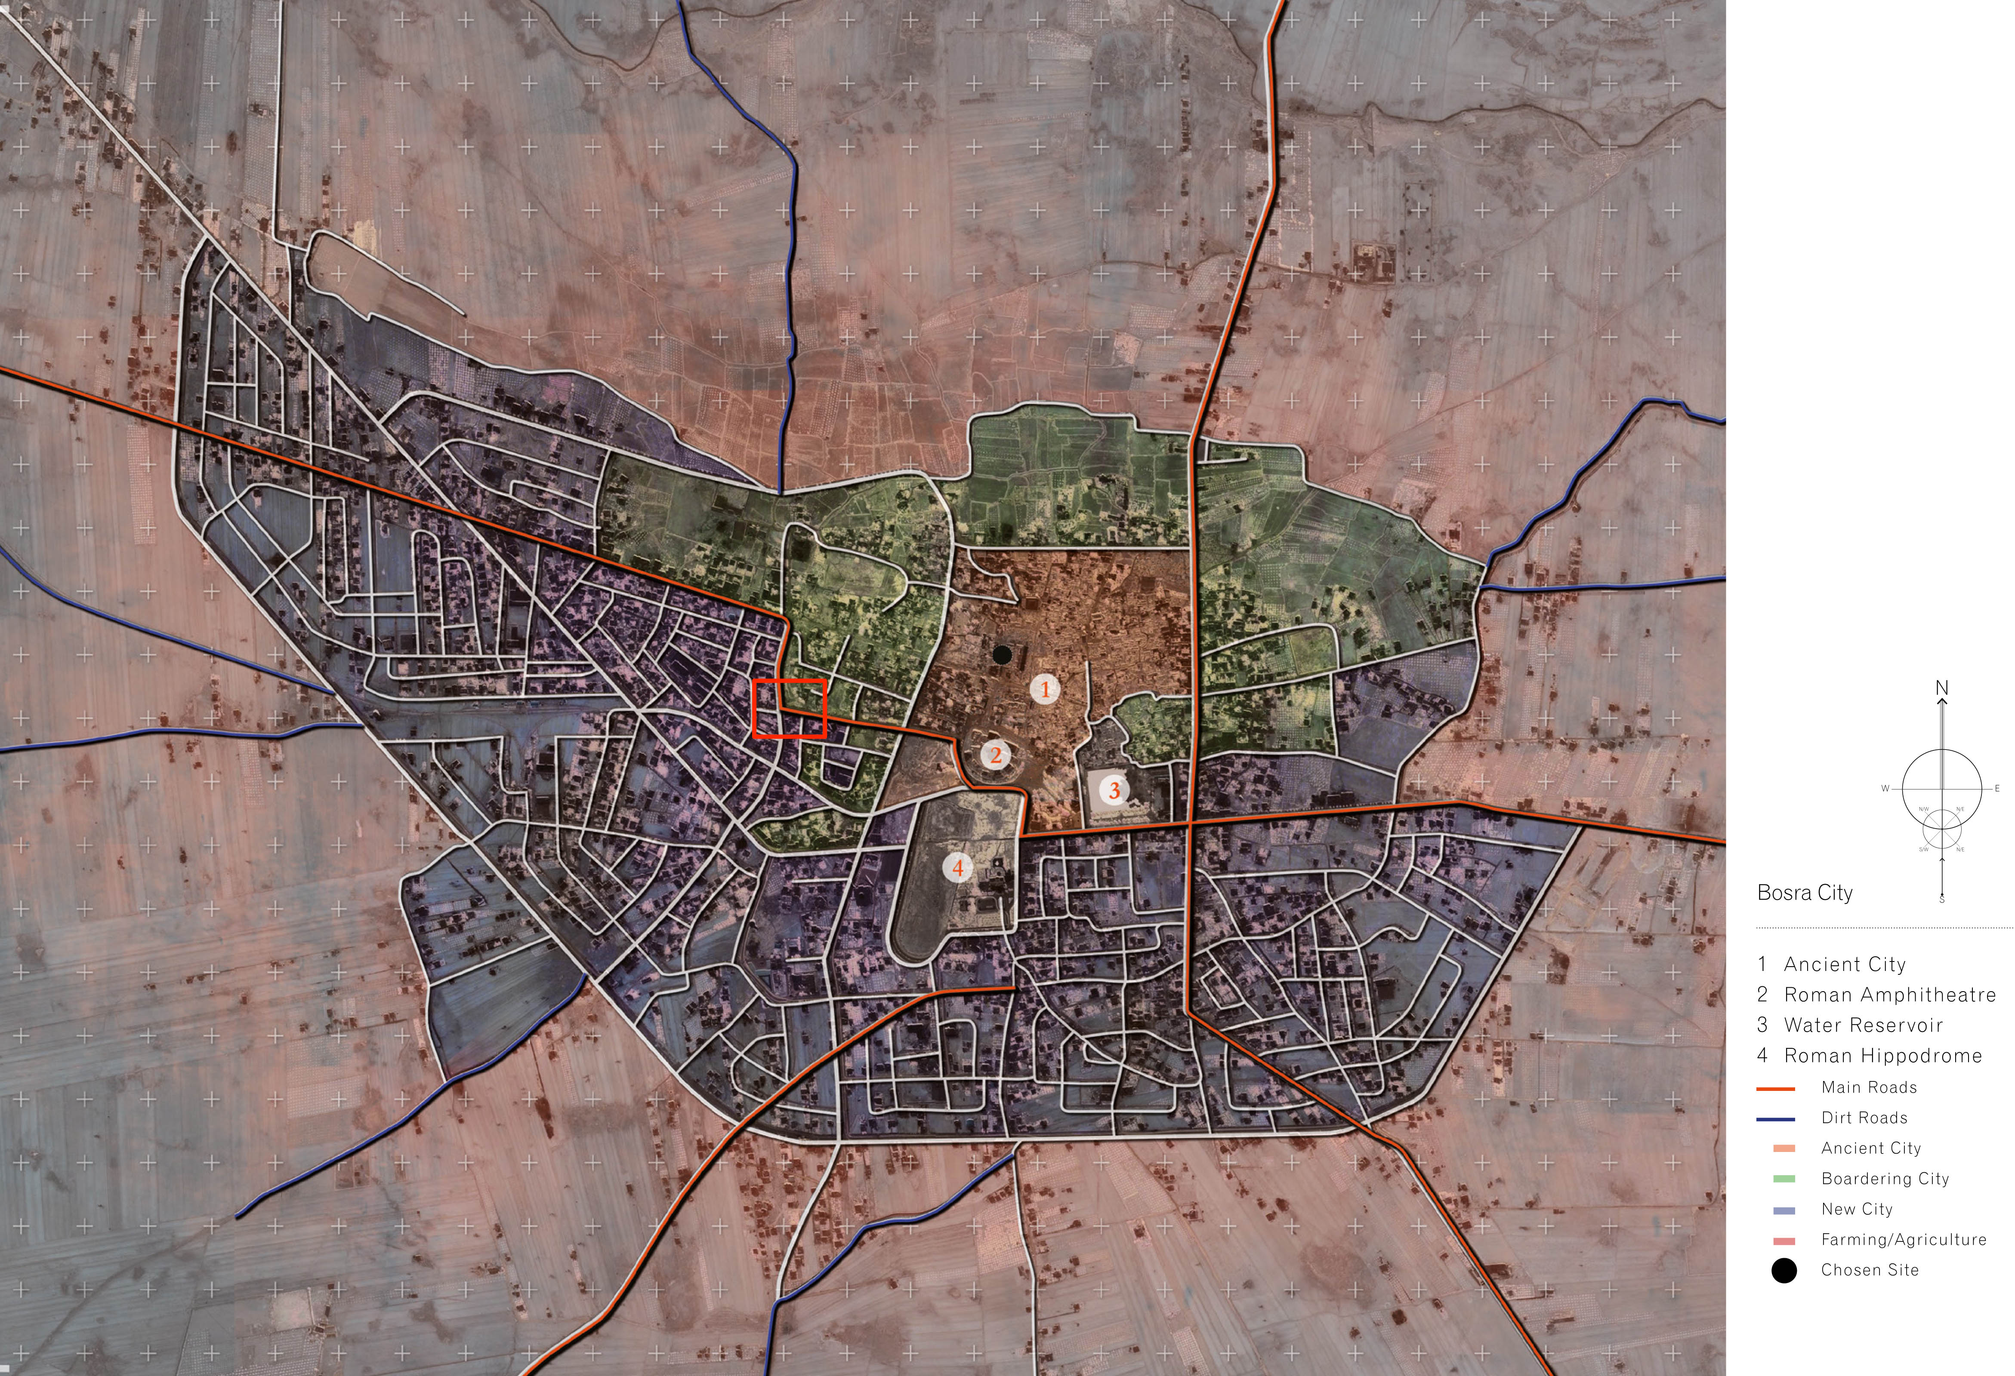
Source: Google Earth (Render by Author)
In Losing Site: Architecture, Memory and Place, Professor Shelley Hornstein of New York University asks: “What happens to the memory of an event if the site where that memory was recorded is demolished, or we only know it through movies or photographs or the story someone recounted to us about it?” This investigation looks at the role of architecture in re-establishing place identity when the previous architectural definers of place no longer exist. According to University of Newcastle Professor Michael J. Ostwald, “Memory is the process wherein the past is recalled in the present. This process typically involves two components – a phenomenological trigger and the associated emotional or psychological response to this trigger. … Similarly, architectural forms and tectonics are assumed to have the ability to control or shape the way in which memory is triggered. In this sense, architecture is perceived to be addressing a collective cultural, societal or transcendent memory.”
Architectural forms relating to temporality can be activated as strategic triggers for place identity. This paper looks at these triggers for place identity in relation to Temporality and the Ruin, Temporality and the Home, and Temporality and the Memorial.
Literature Review
Temporality and the Ruin
The title of this paper, “Heterotopia: After the Fall,” is derived in part from Penelope Haralambidou’s 2007 article “The Fall: The Allegorical Architectural Project as a Critical Method”, and in part from French photographer Vincent J. Stoker’s 2013 exhibition: “Heterotopia, the Tragic Fall”. Haralambidou’s article reflects on how the unbuilt allegorical architectural project can help us relinquish established modes of thinking about architecture and place; Stoker’s exhibition “Heterotopia, the Tragic Fall” specifically challenges the impact of the architectural ruin (Figures 6-9) on our perception of time and place.
Figure 6. “Heterotopia, the Tragic Fall” | Figure 7. “Heterotopia, the Tragic Fall”
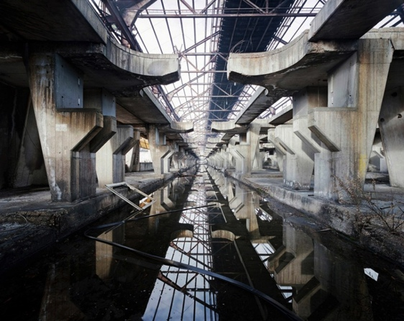 | 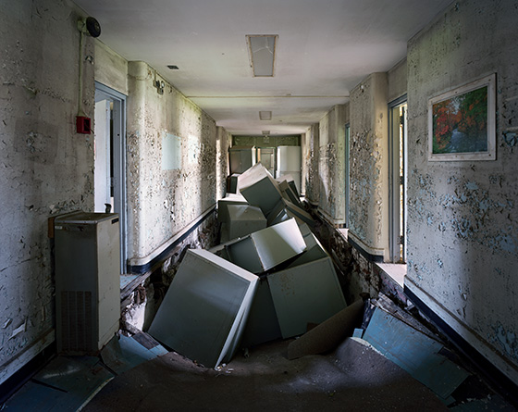
Source: Vincent J. Stoker | Source: Vincent J. Stoker

Figure 8. “Heterotopia, the Tragic Fall” | Figure 9. “Heterotopia, the Tragic Fall”
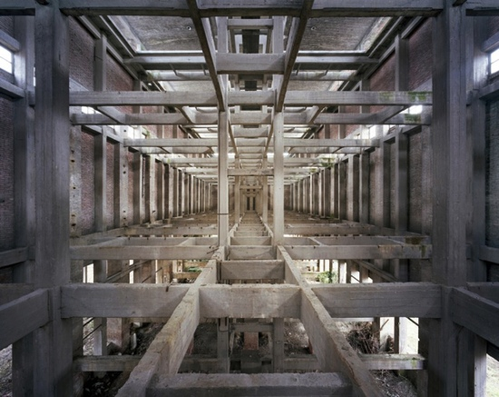 | 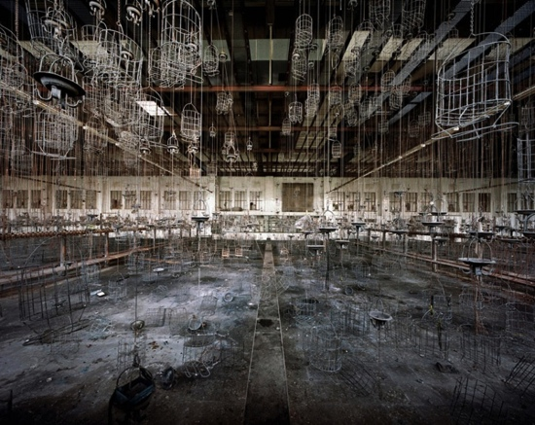
Source: Vincent J. Stoker | Source: Vincent J. Stoker

Bard College Professor Walter Russell Mead describes a heterotopia as neither a utopia nor a dystopia, but rather a place “where things are different – that is, a collection whose members have few or no intelligible connections with one another.” French philosopher Michel Foucault describes heterotopias as places that are ‘neither here nor there’, counter-sites, sites that invert and contest what would be traditionally considered ‘real place. These definitions seem particularly well suited to describing the revised place identity of Bosra-al Sham due to the impact of the Syrian war. By conceiving new architecture in a war-torn city as being sited within a heterotopia, architecture can help returning refugees straddle the fine line that separates utopia from dystopia.
In his exhibition of photographs of ruins “Heterotopia, the Tragic Fall”, Vincent J. Stoker describes how important it is to understand heterotopias in relation to temporality. His collection of images represents “a phenomenological investigation of the ‘other places’… [a dissection of] architectural bodies into their fundamental elements … to reach a better understanding of the world we live in. … Heterotopias can be defined negatively, by what they are not. Here and nowhere, they are neither real, nor utopian but both at the same time. … These other spaces are detached from the commonly established relation to time and have entered a temporality of their own. The linear and sovereign time of the watch is replaced with the slow, soft and suspended time of ruins… The spatial arrangements of these places make it impossible to superimpose them to other constructions. This privilege is granted to them by their power of topographic juxtaposition; a power that enables them to gather incompatible spaces within themselves.”
By detaching both the contemporary and the historic ruins of Bosra from the commonly established relation to time, these damaged artefacts can enter a temporality of their own where the ‘linear and sovereign time of the watch is replaced with the slow, soft and suspended time of ruins’. And in this way, a fundamental component of place identity can be reawakened through the temporary reconceptualization of time in relation to cultural identity.
Ruins can be strategically used to re-establish ‘memory triggers’ within a demolished place. By retaining key remnants of destroyed iconic (such as important civic buildings) and non-iconic (such as typical homes and shops) architecture, place memory can be safeguarded while a site is built anew and new memories are formed.
Temporality and the Home
In The Poetics of Space, Gaston Bachelard wrote: “thanks to the house, a great many of our memories are housed, and … our memories have refuges that are all more clearly defined”. The role of temporality in our identification with ‘home’ is fundamental – even in the context of a home that has been destroyed.
Shelley Hornstein explores memory and place in relation to the home that has been lost or damaged. She argues that when “homes are demolished … [the] notion that architecture is stable, immutable and, above all, permanent, and that home is always safe and present, is shaken by these events. … [The] stuff that carries meaning and memory, is lost over time. Whenever we think of memories, those accumulated during our own formative years in our own home settings come to mind immediately, for better or worse. The visceral response we have to a house in the process of demolition, for example, speaks to the deep pain of loss of a place where memories were formed”.
Hornstein investigates the relationship between place, memory and ‘absent architecture’ by looking at the work of installation artists such as Rachel Whiteread and Iris Häussler. These artists “invite us as viewers to consider that search for a place by returning to our own memories – an equally impossible request – anew. That is, they invite us to take a look at what we never saw even though it was right before our eyes. In this way, we activate the space or gap between a place and our acquired memory of it. In absent or transformed architectures, they set up open narratives that tell stories from the inside out”.
When ‘home’ no longer exists, architecture can help us reacquire place identity by ‘activating the space between a place and our acquired memory of it’. According to Wellesley College Professor of Sociology Lee Cuba and Holy Cross College Professor David Hummon: “From a social psychological perspective, place identities are thought to arise because places, as bounded locales imbued with personal, social, and cultural meanings, provide a significant framework in which identity is constructed, maintained, and transformed. Like people, things, and activities, places are an integral part of the social world of everyday life; as such, they become important mechanisms through which identity is defined and situated.”
Temporality and the Memorial
To help further enhance place identity within a fragmented or demolished site, new architecture can be conceived to be read as a ‘memorial’ – even when it functions programmatically as housing or civic structure. In Residue: Architecture as a Condition of Loss, Ostwald writes: the “memorial is the architectural typology that has the most affinity with the passage of time and an associated robustness that allows it to retain some traces of conceptual functionality”. The strategic form and placement of new architecture into a devastated site can activate memory triggers – and in this way impart qualities of ‘memorial’ to the architecture. According to Ostwald, “The way in which memory operates in spatial and material design is complicated by the extent to which it both shapes architecture and is triggered by it. … While memorials and monuments are more correctly associated with historical reflection, the role of these structures, in forming a link between some historic event and the present day, resonates with the process of remembering. … If space rather than time, is the trigger for memory then this may explain why monuments and memorials – symbolic objects that connect a fixed moment in the past to a continuous sequence of possible moments in the future – may be most effective when placed in a relevant context rather than a displaced context.”
Case Study Analyses
Daniel Libeskind: City Edge (Berlin, Germany 1987)
Speculative architectural case studies – conceived only on paper – can provide important insights into the integrated roles of place identity, memory and temporality. In her article “The Fall: The Allegorical Architectural Project”, Bartlett School of Architecture Senior Lecturer Penelope Haralambidou argues that imaginary architectural projects can use drawing rather than the construction of an actual building to express important ideas. The “allegorical architectural project can be employed to unravel another piece of work, a site or drawing itself by questioning its underlying syntax… Architectural drawing, therefore, can be used as a critical method, distancing the architecture from the construction site and redefining her as an analyst of spatial phenomena…”
Daniel Libeskind’s speculative competition entry “City Edge” for the 1987 I.B.A. Berlin International Building Competition can be investigated as a relevant case study for this investigation relating to war-torn Bosra. Libeskind’s intention was to reunify a fragmented neighbourhood in Berlin – a type of heterotopian ‘counter-site’. His programme integrates housing, offices, and shops with large common spaces inside – effectively creating a holistic new ‘community’. The linear structure is elevated above rather than embedded into the disjointed urban conditions below. Its residents are provided views down onto a West Berlin urban park, as well as the Berlin Wall and East Berlin – signs of the interwoven utopian and dystopian nature of the heterotopia below (Figures 10-11).
Figure 10. Daniel Libeskind “City Edge”
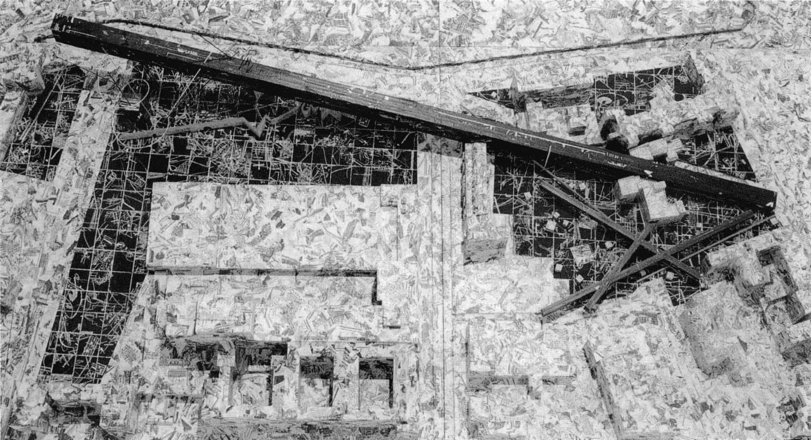
Source: Daniel Libeskind
Figure 11. Daniel Libeskind “City Edge”
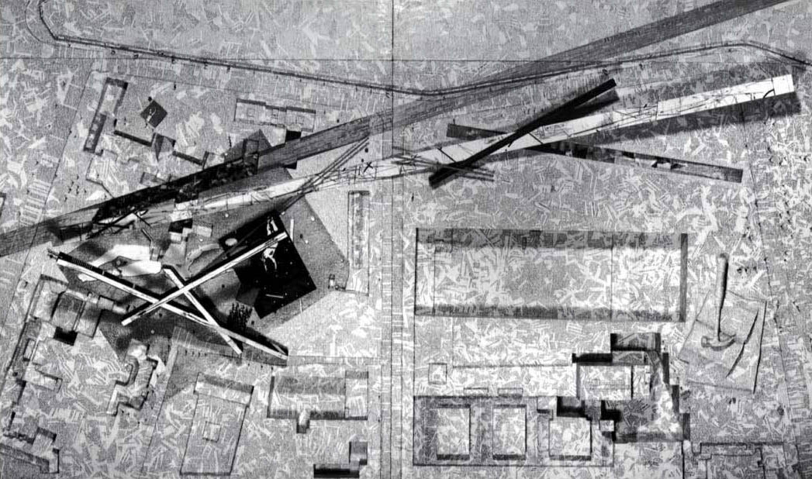
Source: Daniel Libeskind

Libeskind’s design emphasises the: “cuts, fracturing and difficult historical memories in a divided city”. In his published competition brief, Libeskind describes his investigation of place identity in relation to temporality: “Ancient vistas of cities and buildings, like memorable places and names, can be found on maps – the books of the world. … A voyage into the substance of a city and its architecture entails a realignment of arbitrary points, disconnected lines, and names out of place along the axis of Universal Hope. … [One] discovers that what has been marked, fixed, and measured nevertheless lapses in both the dimension of the indeterminate and the spherical. This space of nonequilibrium – from which freedom eternally departs and toward which it moves without homecoming – constitutes a place in which architecture comes upon itself as beginning at the end.”
Emre Arolat Architecture (EAA): Hilton Museum Hotel (Antakya, Turkey 2010)
Built architectural case studies also provide important insights into the integrated roles of place identity, memory and temporality. EAA’s 2010 design for the Antakya Hilton Museum Hotel in Turkey incorporates the temporality of the ruin, the home and the memorial into an expansive 34.000 square meters construction. After discovering significant archaeological artefacts soon after excavation began, the project needed to simultaneously act as both a hotel capable of housing a large number of people, and a ‘heritage museum’ safeguarding and displaying the archaeological ruins below. Like Libeskind’s speculative “City Edge” project, EAA’s built design is elevated above rather than embedded into the disjointed conditions below; and the program integrates housing units, offices and shops with large common gathering spaces – thereby establishing a holistic ‘community’. The programmed areas are spread out under a broad canopy that acts to protect the ruins while allowing them to be viewed from above. In this way, for the ‘community’ above the past becomes an active participant in the present.
Prefabricated hotel room units were suspended in a steel frame and connected by walkways and bridges – taking on the appearance of architectural structures commonly associated with archaeological sites. By locating outdoor terraces and gardens beneath the canopy to encourage a sense of community and public gathering, the ruins below became a fundamental part of the communal setting – with the architecture above safeguarding both the past and the present as related parts of a temporal narrative (Figures 12-14).
Figure 12. EAA: Hilton Museum Hotel, Antakya, Turkey
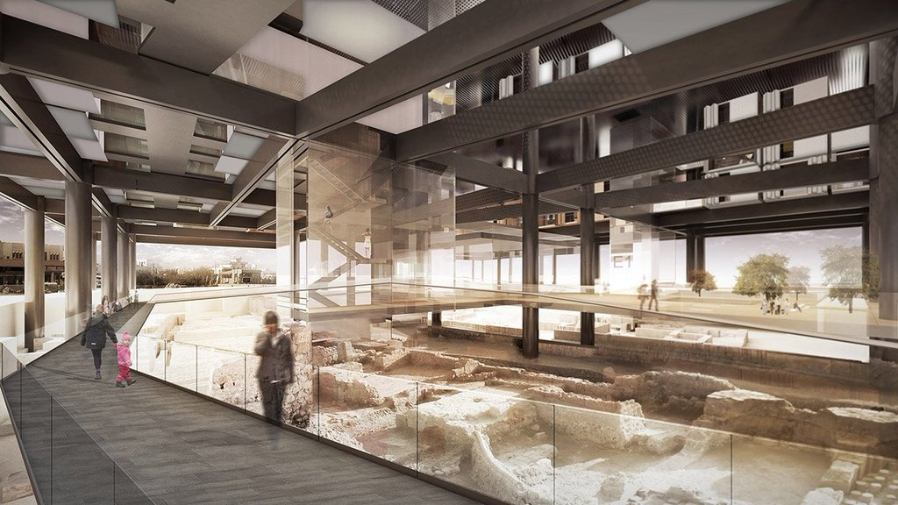
Source: World Architecture Community

Figure 13. EAA: Hilton Museum Hotel, Antakya, Turkey
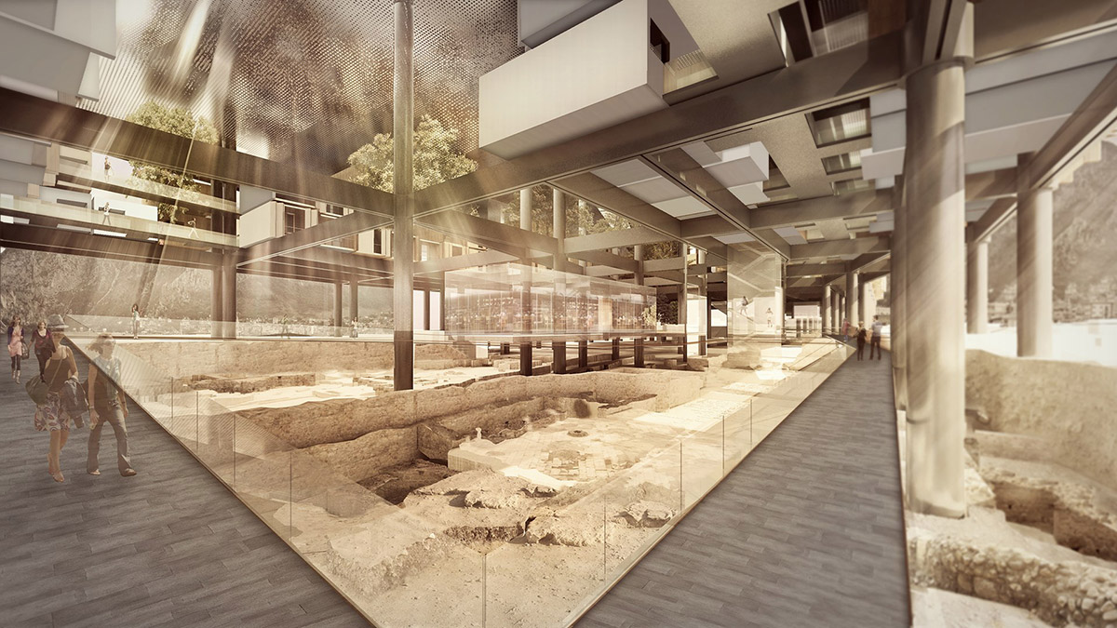
Source: World Architecture Community

Figure 14. EAA: Hilton Museum Hotel, Antakya, Turkey
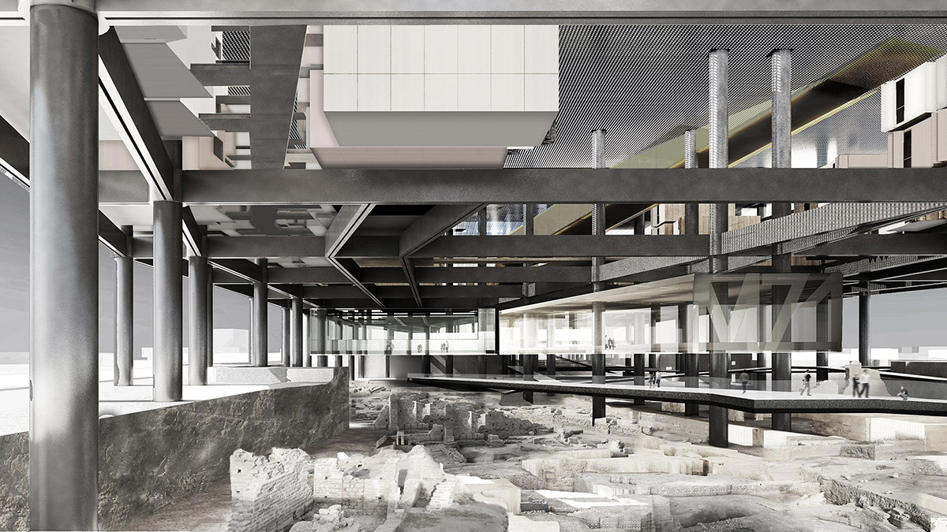
Source: World Architecture Community

Discussion
In the article “Landscape as Palimpsest, Pentimento, Epiphany…”, Sydney University of Technology Professor Rosemary Johnston describes how time and space work dynamically together to establish place identity. A ‘place’ must enable us – on some level – to witness both now and then, similar to pentimento, the condition on a canvas when traces of an earlier painting begin to appear through a more recent painting above. “Time and space are dynamic co-existing elements of landscape; they are ideologically encoded, culturally threaded. Pieced together in many different ways, they tell stories – stories of the present that may unravel into past, stories not only of now but then, not only of here but there. Imagine landscape as a canvas, freshly painted, but with bits of other older paintings showing through, like a pentimento, and with the colours of the world outside the frame seeping in around the edges.”
Once a severely damaged site like Bosra-al Sham is re-conceived as a heterotopia, its fragmented stories can be unravelled and retold – ‘stories not only of now but then, … here but there’. We tend to believe that architecture symbolises permanence – and when this belief is usurped, we become lost. But new architecture can be designed to strategically draw fractured place identity back together again, rather than simply ‘replacing’ the unravelled fragments of a city’s temporal narratives.
In his book Artificial Light: A Narrative Inquiry into the Nature of Abstraction, Immediacy, and other Architectural Fictions, University of Michigan Associate Professor Keith Mitnick reflects: “Despite the fact that we see the meaning of things changing right before our eyes, we nevertheless expect architecture to convey a pre-existing and unchanging reality rather than the provisional staging of one. We want it to be the irreducible structure of physical matter, not an imitation of it. But rather than trying to block the disparity between how we think about things and the way they appear to us, what if architecture embraced the disconnect by allowing things to exist multifariously, with conflicted identities ascribed according to differing sensibilities? It could come clean with the fact that the sense we make out of the world has very little to do with actual objects and material attributes, and everything to do with the way our abstract notions determine our sense and experience of them.”
Conclusion
In reflecting on his exhibition “Heterotopia, the Tragic Fall”, Vincent J. Stoker writes: “Spaces let us see time, this eternal invisible. Architects frustrate Nature by creating ascending shapes. They strive to overcome the forces of Nature which tend to flatten everything. [Architectural ruins evidence] this continuing struggle. A struggle that is fundamental for architecture, this tension in the heart of culture and art. A struggle that eventually even monuments lose. … This last moment is what I call the ‘tragic fall’. A change, more or less violent, plunges the existence of the place from one phase to the other. … [It] is up to the spectators to imagine the other half of this tragic circle by creating their own version of the places’ glorious youth. To see the tragic fall in everything and themselves. … Ruins have a constructive power. They teach us that humanity makes mistakes; this is what must not be forgotten. These terrible and monumental mutilations, vestiges of History, remind us of the impermanence of our existence” (Figures 15-16).
Figure 15. War damage, Bosra, Syria | Figure 16. War damage, Bosra, Syria
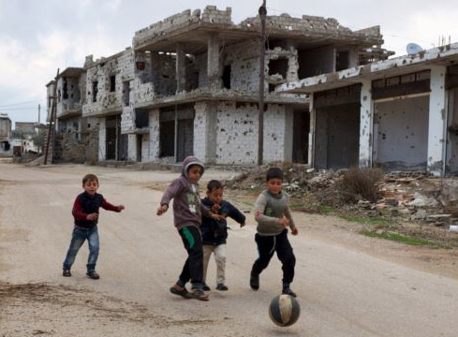 | 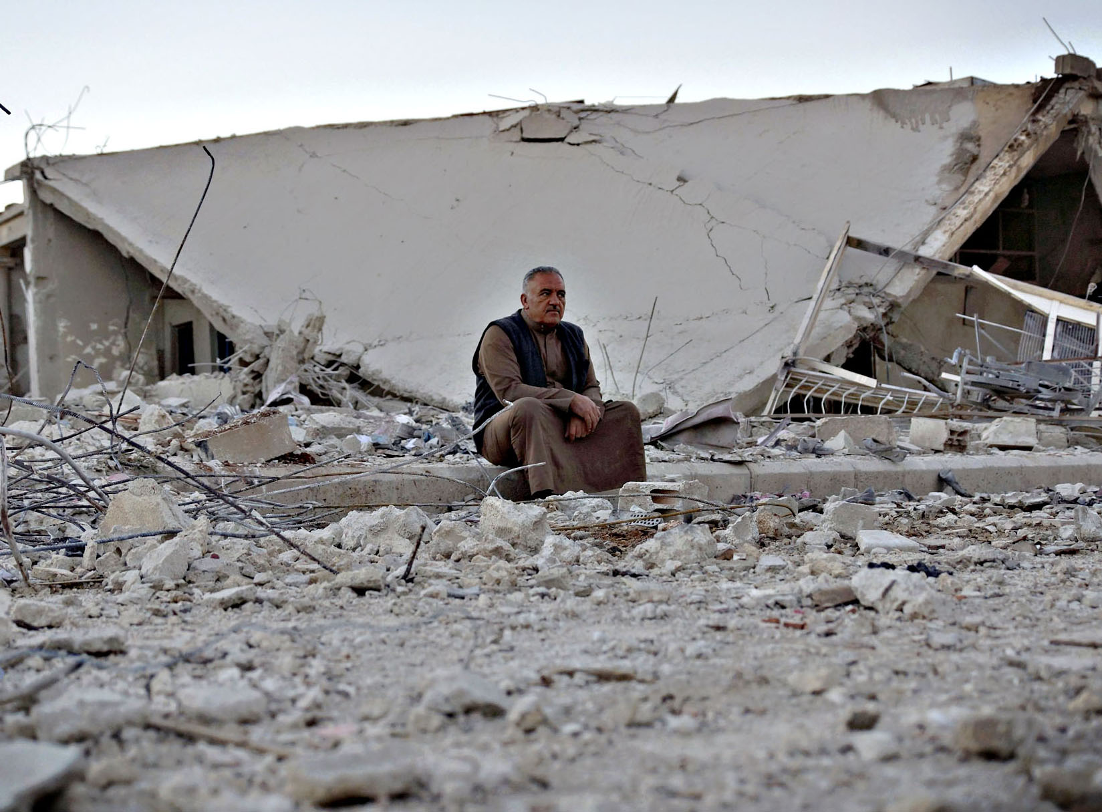
Source: Alaa Al-Faqir / Reuters | Source: Alaa Al-Faqir / Reuters

That struggle that eventually even monuments lose is Stoker’s ‘tragic fall’, the descent into heterotopia. And architecture has a fundamental role it must play in restructuring and reawakening place identity through the temporal reinterpretation of war-damaged sites as heterotopias – after the fall. Ruins can be preserved, sensitively and safely, and reincorporated back into the fabric of the rebuilt city to ensure place identity is ongoing rather than lost and started again anew (Figures 17-20).
Figure 17. Berlin Ruins preserved as a permanent memorial: Kaiser Wilhelm Memorial Church (1890s) destroyed during WWII bombing | Figure 18. Berlin Ruins preserved as a permanent memorial: Heritage Berlin Castle (1443) destroyed during WWII bombing
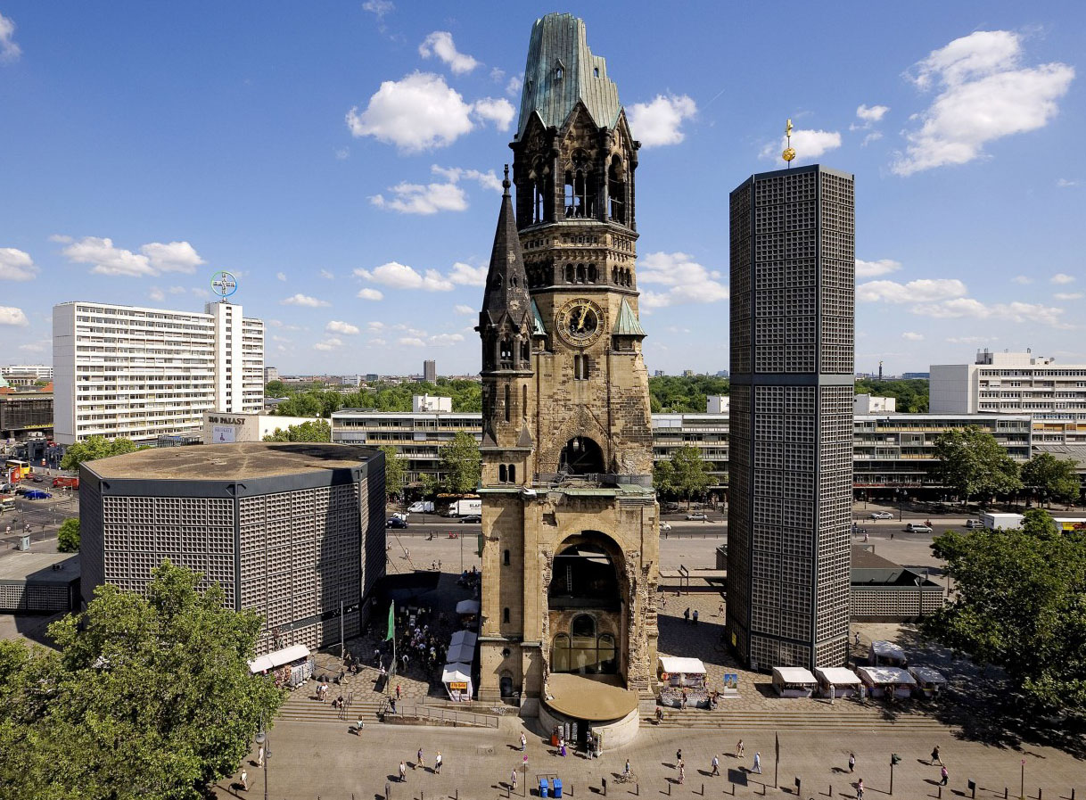 | 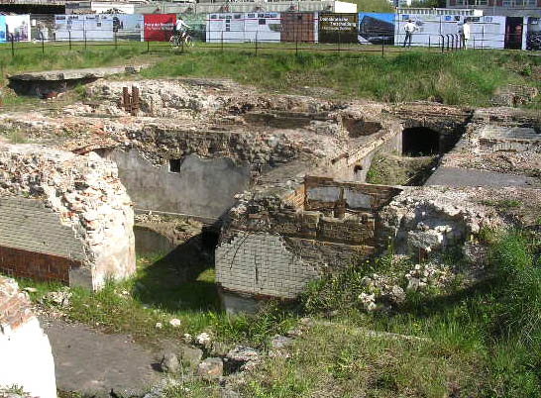
Source: Collectors Weekly | Source: Bearsac

Figure 19. London Ruins preserved as a permanent memorial: Remaining stone wall of Greyfriars Passage (1687), after the WWII Blitz | Figure 20. Hiroshima Ruins preserved as a permanent memorial: Prefectural Industrial Promotion Hall (1915) after the atom bomb
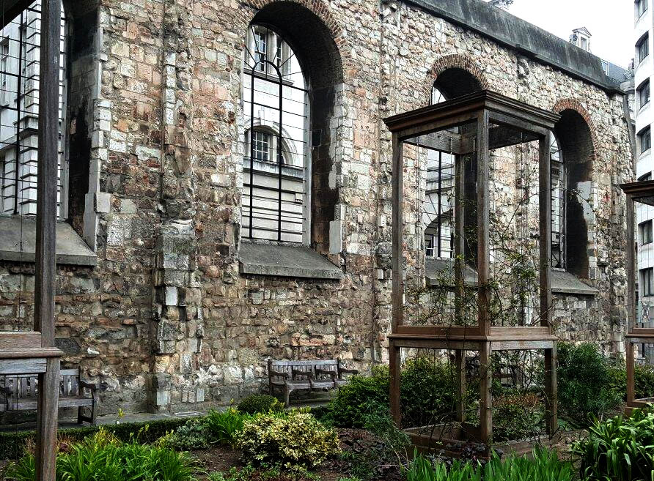 | 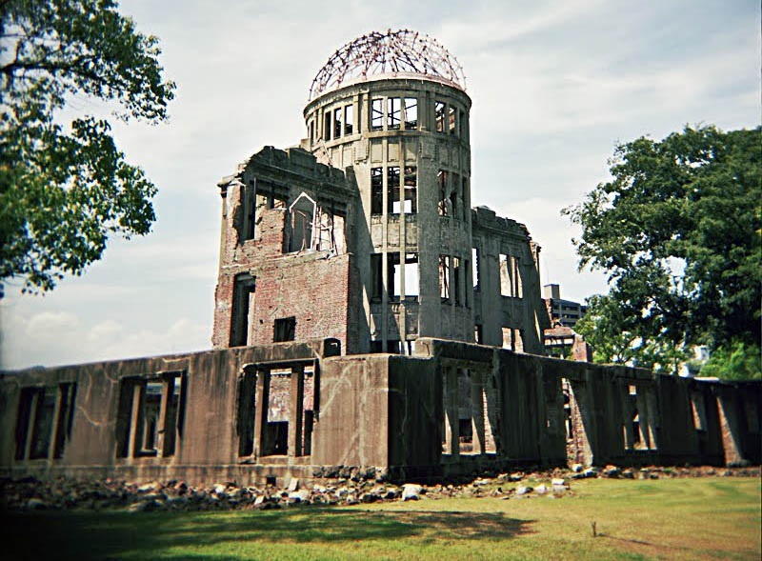
Source: Amin G | Source: Animatronyx
In conclusion, I would like to leave you with Emily Orley’s reflections on a three-word quote from the author James Joyce: “places remember events”. “James Joyce scribbled the words, ‘places remember events’ in the margin of his notes for Ulysses. … [What if] places, as anthropomorphised entities, really could remember? What impact would this have on our own behavior, as visitors in those places? How might this serve as the stimulus for the production of artistic and critical work in and about a particular place? And finally, how might it affect how we, in turn, remember the place ourselves?” (Figure 21)
Figure 21. Downtown Christchurch, New Zealand during the 2011 Earthquake
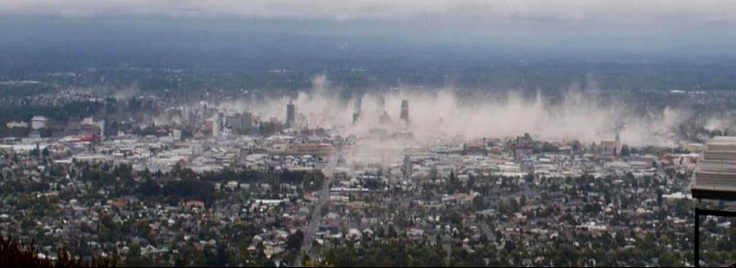
Source: The Cascadia Courier

References
Bachelard, Gaston. 1994. The Poetics Of Space. Boston, MA: Beacon Press.
C​atling, Charlotte Skene. 2014. “The Naked Truth Architecture or Revolution.” The Architectural Review. Issue Number 1412, Volume CCXXXVI, Oct.
Cuba, Lee and David M. Hummon. 1993. “A Place to Call Home: Identification with Dwelling, Community, and Region.” The Sociological Quarterly, volume 34 (no. issue 1).
Curtis, William JR. 21 Sept 2011. “Daniel Libeskind (1946- )”, The Architectural Review. Web. 27 June 2016. <http://www.architectural-review.com/archive/reputations/daniel-libeskind-1946-/8620025.fullarticle>
“EAA’s Antakya Hilton Museum Hotel is Created by Stack of Boxes that Protect Archeological [sic] Ruins.” 14 Dec. 2015. World Architecture Community. Web. 25 June 2016. <http://www.worldarchitecture.org/architecture-news/cezmf/eaas-antakya-hilton-museum-hotel-is-created-by-stack-of-boxes-that-protect-archeological-ruins.html>
Foucault, Michel. March 1967. “Of Other Spaces: Utopias and Heterotopias.” (“Des Espace Autres.” Translated by Jay Miskowiec), Architecture / Mouvement / Continuité. October 1984.
Frye, Northrop. 1963. The Educated Imagination. Toronto, ON, Canada: CBC Enterprises.
Ginsburg, Robert. 2004. The Aesthetics of Ruins. Amsterdam and New York: Rodopi.
Haralambidou, Penelope. 2007. “The Fall: the Allegorical Architectural Project as a Critical Method.” Critical Architecture. Edited by Jane Rendell, Jonathan Hill, Murray Fraser and Mark Dorrian. London and New York: Routledge: 225-236.
Hornstein, Shelley. 2011. Losing Site: Architecture, Memory and Place. Farnham, Surrey, UK: Ashgate.
Johnston, Rosemary Ross. 2005. “Landscape as Palimpsest, Pentimento, Epiphany: Lucy Maud Montgomery’s Interiorisation of the Exterior, Exteriorisation of the Interior.” CREArTA 5: 13-31.
Jodidio, Philip and Suha Özkan. 2013. EAA: Emre Arolat Architects. New York: Rizzoli International Publications, Inc.
Mead, Walter Russell. Winter 1995–1996. “Trains, Planes, and Automobiles: The End of the Postmodern Moment.” World Policy Journal volume 12 (no. issue 4): 13–31.
Marotta, Antonello. 2007. Daniel Libeskind. Palermo: Edistampa.
Mitnick, Keith. 2008. Artificial Light: A Narrative Inquiry into the Nature of Abstraction, Immediacy, and other Architectural Fictions. New York: Princeton Architectural Press.
MoMA. 1987. “Daniel Libeskind’s Brief for the City Edge Competition, Berlin.” Reprinted Fall 2011 by Stephen Andenmatten, Caitlin Walsh, James Wisniewski, Jewish Museum Berlin. Web. 27 June 2016. <https://issuu.com/stephenandenmatten/docs/casestudy> 46.
Orley, Emily. 2012. “Places Remember Events: Towards an Ethics of Encounter,” Liminal Landscapes: Travel, Experience and Spaces In-between. London and New York: Routledge.
Ostwald, Michael J., Chris Tucker and Michael Chapman. 2007. Residue: A Condition of Loss. Melbourne, Vic. Australia: RMIT University Press.
Ramirez, Andres. 2015. Other Spaces, Plural Narratives of Place in Berlin’s SO 36. Berlin: Universitätsverlag der TU.

Rinke, Andreas. “Germany’s Merkel says refugees must return home once war is over”. Reuters. Sat Jan 30, 2016. Web. 25 June 2016. < http://www.reuters.com/article/us-europe-migrants-germany-refugees-idUSKCN0V80IH >
Schalk, Meike. 2014. “The Architecture of Metabolism. Inventing a Culture of Resilience.” Arts. volume 3 (no. issue 2): 18 Oct.
Stoker, Vincent J. 2012. “Heterotopia, the Tragic Fall.” 11 July 2012. Web. 25 June 2016. < http://socks-studio.com/2012/07/11/heterotopia-the-tragic-fall-by-vincent-j-stoker>
Wurster, Reed. 2016. The Last House. MArch(Prof) Thesis (Supervisor: Daniel K. Brown), Victoria University of Wellington, New Zealand.

Sources of Figures
Figure 1: Google Earth. Web. 25 June 2016.
Figure 2: Google Earth. Web. 25 June 2016.
Figure 3: David Wethey, NZPA/Assoc. Press. Web. 25 June 2016. <http://archive.boston.com/bigpicture/2011/02/christchurch_earthquake.html>
Figure 4: Mark Baker, Associated Press. Web. 25 June 2016. < http://archive.boston.com/bigpicture/2011/02/christchurch_earthquake.html>
Figure 5: Google Earth (With Additional Render by Author)
Figures 6-9: Vincent J. Stoker. Web. 25 June 2016. <https://translate.googleusercontent.com/translate_c?depth=1&hl=en&prev=search&rurl=translate.google.co.nz&sl=fr&u=http://vincent-j-stoker.com/index.php%3Fid%3D3&usg=ALkJrhhbw-KbqU_kEfxUwVTeK_3uG_7_yA>
Figure 10: Mark Dorrian. Chapitre V. Architecture’s “Cartographie Turn,” 61-72. Web. 25 June 2016. <http://books.openedition.org/editionscnrs/4291>
Figure 11: Daniel Libeskind. Web. 25 June 2016. <http://www.daniellaondesign.com/blog/deconstructivist-architecture>
Figures 12-14: World Architecture Community. Web. 25 June 2016. http://www.worldarchitecture.org/architecture-news/cezmf/eaas-antakya-hilton-museum-hotel-is-created-by-stack-of-boxes-that-protect-archeological-ruins.html>
Figure 15: Reuters / Voice of America. Web. 25 June 2016. <http://www.voanews.com/content/diplomats-make-push-for-syria-cease-fire-as-deadline-approaches/3207339.html>
Figure 16: Alaa Al-Faqir / Reuters. Web. 25 June 2016. <http://blogs.ft.com/photo-diary/tag/damage>
Figure 17: Collectors Weekly. Kaiser Wilhelm Memorial Church. Web. 25 June 2016. < http://www.collectorsweekly.com/articles/what-america-can-learn-from-berlins-struggle-to-face-its-violent-past >
Figure 18: Ruins of Berlin Castle after bombing on 3rd February 1945 during World War II. Web. 25 June 2016. < http://www.bearsac.com/Germany/germany.htm >
Figure 19: Amin G. Trip Advisor. Beautiful Ruins. 25 June 2016. Web. < https://www.tripadvisor.co.nz/ShowUserReviews-g186338-d630094-r357872586-Greyfriars_Passage-London_England.html#photos;geo=186338&detail=630094&ff=179112061&albumViewMode=hero&albumid=103&baseMediaId=179112061&thumbnailMinWidth=50&cnt=30&offset=-1&filter=2 >
Figure 20: Animatronyx. Atom Bomb Dome. 25 June 2016. Web. < http://animatronyx.blogspot.co.nz/2009/10/atomic-bomb-dome-photos.html >
Figure 21: “The Canterbury Earthquakes in New Zealand,” The Cascadia Courier. Thursday, January 24, 2013. Web. 25 June 2016. < http://www.thecascadiacourier.com/2013_01_01_archive.html >

Rinke, Andreas. “Germany’s Merkel says refugees must return home once war is over”. Reuters. Sat Jan 30, 2016. Web.
Shelley Hornstein, Losing Site: Architecture, Memory and Place, 2.
Michael J. Ostwald, Residue: Architecture as a Condition of Loss, 21.
Walter Russell Mead, "Trains, Planes, and Automobiles: The End of the Postmodern Moment," 13.
Michel Foucault, “Of Other Spaces: Utopias and Heterotopias,” 3-4.
Vincent J. Stoker, “Heterotopia, the Tragic Fall,” Web.
Gaston Bachelard, The Poetics of Space, 9.
Shelley Hornstein, Losing Site: Architecture, Memory and Place, 82-83.
Shelley Hornstein, Losing Site: Architecture, Memory and Place, 84.
Lee Cuba and David M. Hummon, “A Place to Call Home: Identification with Dwelling, Community, and Region,” 112.
Michael J. Ostwald, Residue: Architecture as a Condition of Loss, 15.
Michael J. Ostwald, Residue: Architecture as a Condition of Loss, 22-23.
Penelope Haralambidou, “The Fall: The Allegorical Architectural Project as a Critical Method,” 225-226.
Antonello Marotta, Daniel Libeskind, 132.
William JR Curtis, “Daniel Libeskind (1946- )”, The Architectural Review. Web.
MoMA, “Daniel Libeskind’s Brief for the City Edge Competition, Berlin,” 46
Philip Jodidio and Suha Özkan, EAA: Emre Arolat Architects, 27.
“EAA’s Antakya Hilton Museum Hotel is Created by Stack of Boxes that Protect Archeological [sic] Ruins,” World Architecture Community, Web.
Rosemary Ross Johnston, “Landscape as Palimpsest, Pentimento, Epiphany…,” 13.
Keith Mitnick, Artificial Light: A Narrative Inquiry into the Nature of Abstraction, Immediacy, and other Architectural Fictions, 27.
Vincent J. Stoker, “Heterotopia, the Tragic Fall.” Web.
Emily Orley, “Places Remember Events: Towards an Ethics of Encounter,” 36.

