The effect of nanoparticle and mesoporous TiO₂ additions on the electronic characteristics of reduced graphene oxide nanocomposites with zinc oxide under UV irradiation
Sara Abbaspourª, Amirabbas Nourbakhsh^{b*}, Reza Ebrahimiª, Hamid Ghayourª, Kenneth J.D. Mackenzie^{c*}
ªAdvanced Materials Research Center, Department of Materials Engineering, Najafabad Branch, Islamic Azad University of Najafabad, PO Box 85141-43131 Najafabad, Isfahan, Iran. sara_4695@yahoo.com, rezaebrahami@1aun.ac.ir, h-ghayour@iaun.ac.ir
^{b}Department of Materials Science and Engineering, Shahreza Branch, Islamic Azad University Shahreza Branch, Pasdaran Street, Shahreza 86145-311, Isfahan, Iran. anourbakhs@yahoo.com
^{c}Macdiarmid Institute for Advanced Materials and Nanotechnology, Victoria University of Wellington, P.O. Box 600, Wellington, New Zealand. kenneth.mackenzie@vuw.ac.nz
Tel +64 4 5891948
*Corresponding authors, Professor Kenneth J.D.Mackenzie,Dr.Amirabbas Nourbakhsh

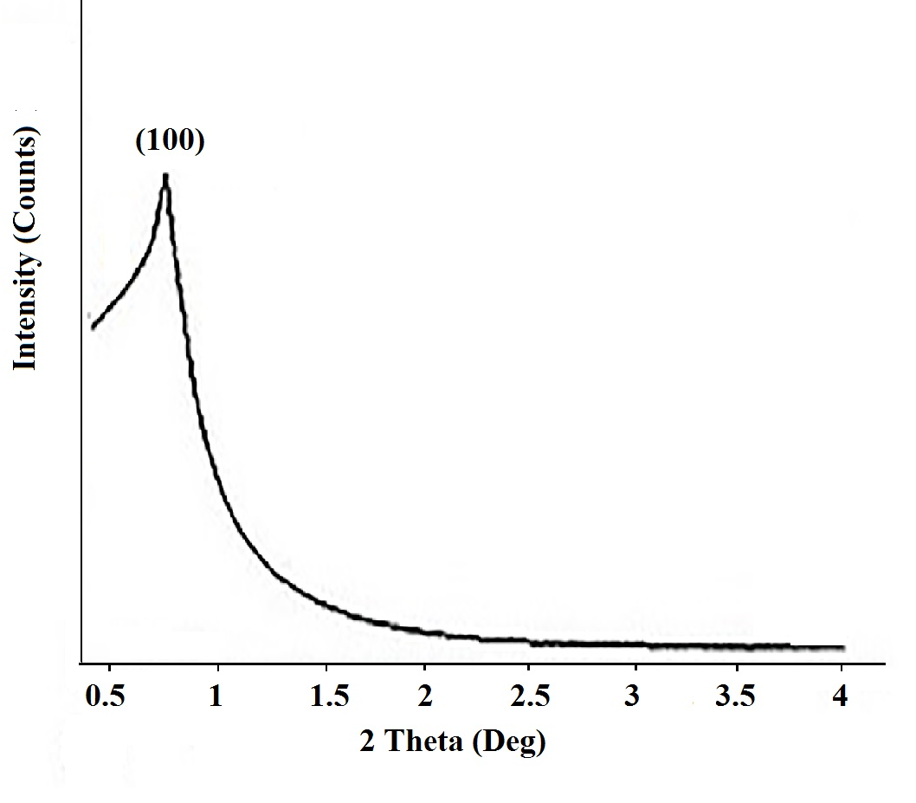
Figure S1. low-angle XRD pattern of mesoporous TiO₂

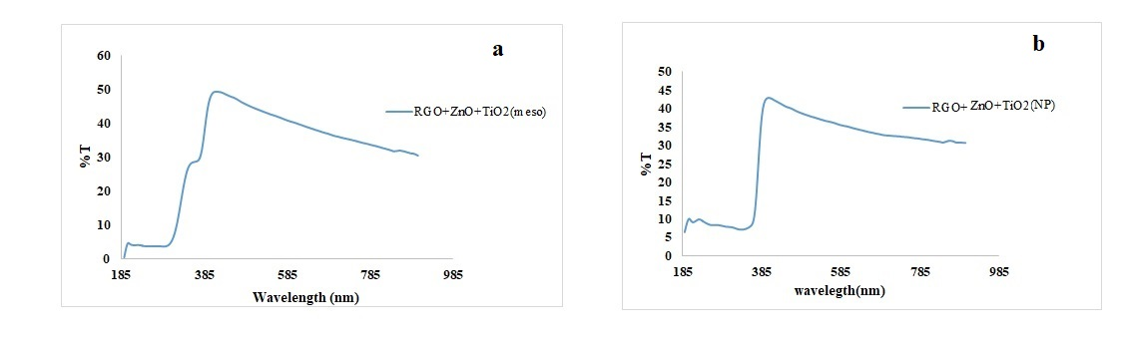
Figure S2.Transmittance versus wavelength a) RGO-Zno-TiO₂ (Meso), b) RGO-ZnO-TiO₂ (Nano)

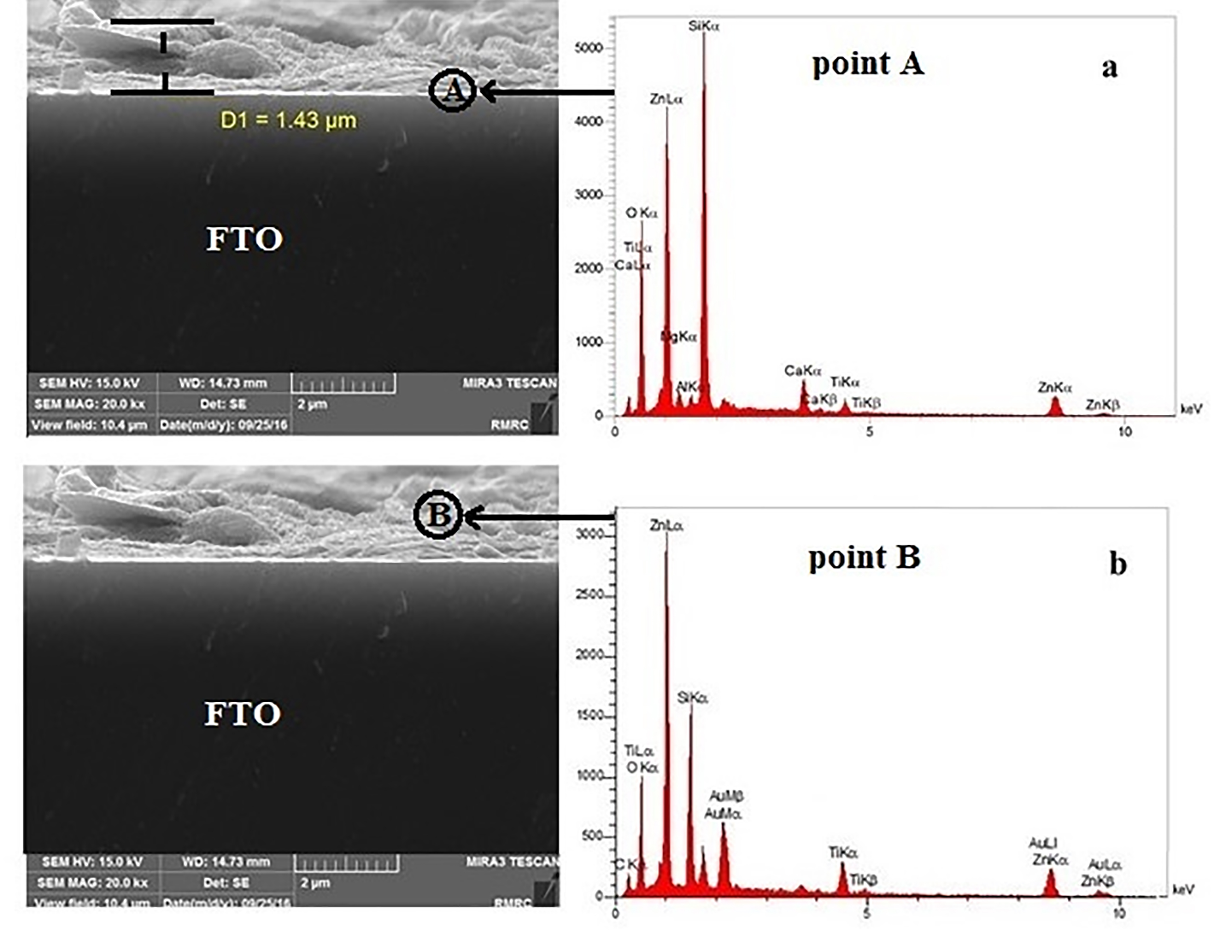

Figure S3. FE-SEM image and EDS spot analysis of the cross-section of the FTO-RGO-ZnO-(nanoparticle) composite at the FTO interface (a) and within the deposited layer (b).

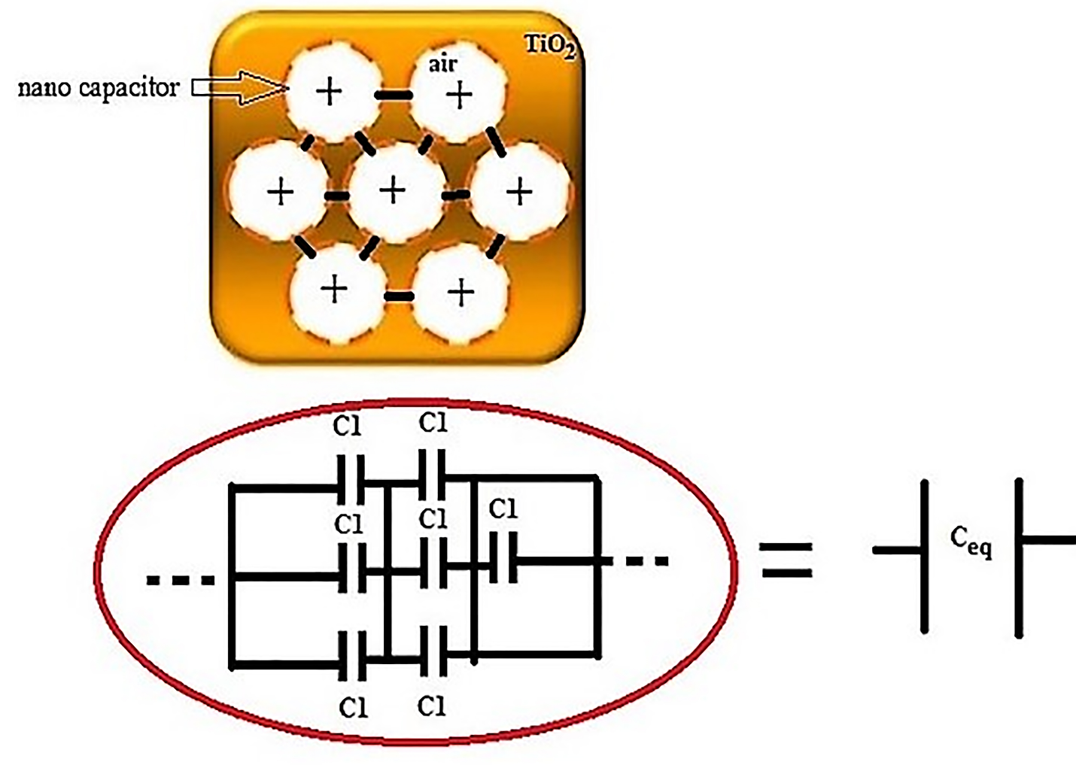
Figure S4. Schematic diagram of the nano capacitor formed within the mesoporous TiO₂ structure

Table S1. Thickness of the sample layer determined by SEM. Sample designations as in Table 1.
Thickness (µm) | Sample
1.41 | 1
1.43 | 2
1.45 | 3
1.42 | 4

