We’re online......New Zealand senior secondary school students’ experience of learning online during the first Covid-19 closure of schools.

Anne Yates, Louise Starkey, Ben Egerton and Florian Flueggen
Summary report, August 2020
Contact: Anne.Yates@vuw.ac.nz

Executive Summary
Teaching New Zealand secondary students at home during Covid-19. Some research findings.

In June 2020 we surveyed year 12 and 13 students about their experiences of learning online during lockdown in March-May. 1,975 students from across New Zealand shared their thoughts about this experience.
The year 12 and 13 students who responded to the survey provided insight into their experiences. A lack of access to technology or learning was reported by less than 1% of the students. Half the students spent less time on school work than they would normally spend at school and a similar number felt they learnt less. Most students (60%) had up to 6 hours a week of scheduled synchronous activities and found they had to manage their own time studying. Some students found this difficult, others liked this aspect of lockdown. Approximately 10% of students had more than 18 hours scheduled classes.
Students were concerned about being isolated from their friends, their academic progress, their well-being, motivation and managing their time. However, they provided examples of teaching through supportive pedagogies that worked well for students. These included a variety of learning activities and supported students through feedback and positive social interactions.
Students were asked what they would like to change in their school as a result of what they learnt through learning at home. The key aspect identified was that they would like to have greater flexibility in their learning.

Acknowledgement
The research team of Anne Yates, Louise Starkey, Ben Egerton and Florian Flueggen would like to thank all the schools and students who agreed to take part in this project. Without you these insights would not be possible. We hope these findings will be useful for any future planning around emergency remote education, but also for the future of education in the digital world.

Contents
We’re online......New Zealand senior secondary school students’ experience of learning online during the first Covid-19 closure of schools. 1
Executive Summary 2
Acknowledgement 2
Introduction 4
Methods 4
Findings 4
Time spent on schoolwork and perceived learning. 4
What students found difficult. 5
What teachers did that helped students to be successful. 6
Learning activities that worked and did not work. 7
Positive subject specific experiences 8
Learning from the experience. 8
Conclusion. 10
Bibliography. 11
Appendix 1 12

Introduction
This project explored New Zealand senior secondary school students’ experience of emergency online learning at home during the Covid-19 pandemic of 2020, when schools were closed between the 25th March 2020 and 18th May 2020. We aimed to find out:
- Student experience of online learning during this time
- What helped and what made it difficult for students to learn online at home.

Methods
A mixed method approach was used with data being gathered through an online survey using the Qualtrics survey tool. Year 12 and 13 students from New Zealand schools were invited to take part. They were recruited through their schools with emails being sent to school principals or deputy principals of schools with at least 100 students aged 16 years and over (total of 348 schools). Principals, or deputy principals, were invited to forward the survey link to the relevant students of their school. Participating students could choose to enter a draw for a newly released Playstation console to encourage participation. A total of sixty schools and 1,975 students from across New Zealand participated of which 1045 were Year 12 and 930 Year 13.

Findings
Time spent on schoolwork and perceived learning.
We asked several questions with regards how many timetabled classes students were expected to attend, how many hours they spent on school work, whether this was more or less time than what they spent at school and whether they thought they learned more or less than they did at school. Time spent learning is a reliable predictor of opportunity to learn (Reimers & Schleicher, 2020), so we thought it important to establish what the students’ perceptions of this were.
The number of timetabled classes (per week) students were expected to attend varied from zero hours to over 18 hours with the majority of students (1200) being asked to attend between one and six hours.

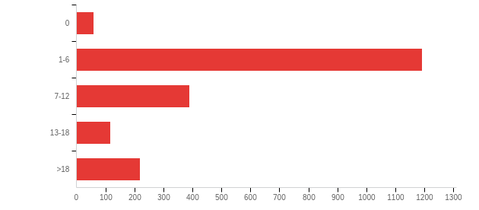
Figure 1. Number of timetabled classes students were expected to attend each week.
The number of hours students said they spent on schoolwork ranged from less than one hour per day to more than four hours (Figure 2), which for about half of them was less than time spent at school. Although, the other half claimed they spent about the same or more time on schoolwork while at home (Figure 3).
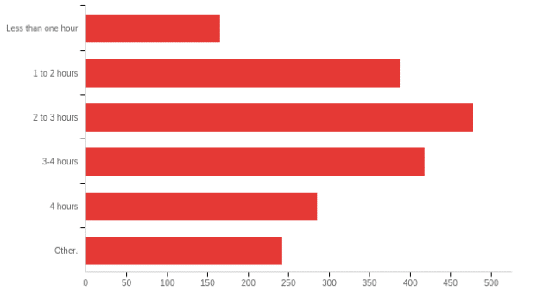Figure 2. How much time usually spent on schoolwork at home each day during Covid-19 | 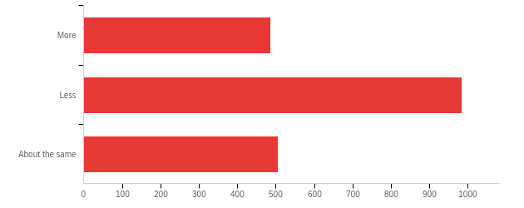  Figure 3. Is this more or less than time usually spent learning when at school?
In addition, slightly over half (51%) thought they learned less at home than at school with 21% saying they learned more and 28% thinking they learned about the same.
Responses to the question of whether students felt that they learned more at home than they do at school were analysed in relation to participants’ responses to the other questions to identify trends. For this analysis participants were distinguished based on their responses to the other questions and the percentages of these were regarded that felt they learned less at home, the same at home, or more at home than they would in school.
The less time students spent on schoolwork at home relative to school, the more likely they were to feel they learned less at home. This is a moderate trend and students who spent more time did not necessarily learn more at home. A third of the students reported they spent less time on schoolwork and that they learned less (Table 1).
Table 1. Time students spent learning at home compared to at school in relation to how much they learned in the two contexts.
Time spent on schoolwork at home | Learned less at home | Learned about same at home | Learned more at home
Less time | 66% (648) | 21% (207) | 13% (128)
Same amount of time | 37% (185) | 40% (203) | 23% (118)
More time | 36% (174) | 29% (141) | 35% (171)
The table is to be read as of the students who spent less time studying at home than they would at school, 66% felt they learned less at home than they would at school. The numbers in the parentheses are the absolute numbers for the percentages provided.

What students found difficult.
For most students the hardest part of learning from home was finding the motivation to study. They linked their lack of motivation to contextual issues which included: family obligations such as looking after siblings or helping out at home or on the farm; distractions like Netflix or online shopping; inaccessibility of teacher or peer help; lack of extrinsic consequences; and the lack of distinction between home and school. Without the extrinsic drivers of school, routine, consequences, resources and easy access to teacher and peer support, many students reported being unable to find the intrinsic motivation to study. Some recognised that lack of time management affected their motivation and learning and attributed this to ‘not having the routine of school, e.g. getting up early, having bell times and specified breaks’.
Others found the lack of immediate support difficult with many saying it was much easier to get help when in class from classmates and teachers. Contacting each other and/or the teacher during lockdown was difficult for some students in terms of timing and feeling uncomfortable asking for help through phone calls or email.
While synchronous use of technology was appreciated in terms of being emotionally supportive, long synchronous Zoom or Teams sessions were difficult. Collaborating on unfamiliar platforms such as Zoom ‘felt unnatural’ because only one person could talk and the teacher dominated, classmates turned off videos and microphones and didn't participate and some students simply did not attend. Some students reported feeling uncomfortable asking questions in front of a class on Zoom, and sporadic scheduling was also problematic for some who found it hard ‘remembering the times that the video calls were happening’ or resented ‘waking up for the early Teams calls’. Over half (53%) of the students reported that it was hard to collaborate through technology preferring the proximity of working together in a classroom.
‘No one talks in online classes except the teacher’
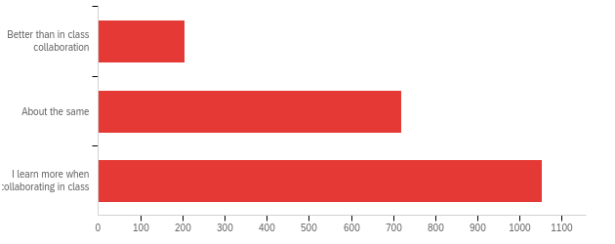
Figure 4. Helpfulness of collaborating online.
Another sentiment was that some students perceived that teachers set more work than they would have at school. They reported that inconsistency among teachers and subjects difficult to deal with. This included inconsistent and uneven workload among subjects and timing clashes for synchronous lessons.
For many students missing friends and social connection was difficult both in terms of learning and for social and emotional support.

What teachers did that helped students to be successful.
Teacher actions that helped students to continue to learn included: regular communication with students (checking in on them), clear instructions, guidance on managing time, empathetic discussions, multiple ways of checking learning progress (e.g. gamification, peer and teacher feedback), using multimedia resources, well-managed discussions, fun collaborative activities, authentic experiences which are cognisant of home resources and the social context, and providing a structure that encouraged motivation while also giving flexibility to learn at their own pace. For example, the independent use of time was supported by teachers who curated learning management systems to provide clear plans and multimedia materials which enabled students to meet and evaluate their academic goals. Without teacher guidance and encouragement many students struggled to manage their time.
Supportive teachers were cognisant of students’ individual situations and provided support for their wellbeing, this seemed particularly relevant in this emergency situation, which some students experienced as stressful and where their normal support networks were limited. A second aspect overlaps with motivation in that supportive pedagogy helped students organise their time and stay focused in the face of distractions. An important first step in supportive pedagogy is preparing students to be independent and to take responsibility for their own learning.

Learning activities that worked and did not work.
Learning activities that worked for students included direct instruction, receiving feedback, multimedia resources, class discussions, clear communication, interactive activities and gamification.
Direct instruction was considered on efficient way to develop academic knowledge by those who were time conscious. They liked listening to the teacher and taking down notes in a lecture-styled way. Some found this more straight to the point and less time consuming than ‘active activities’.
Watching movies, YouTube or teacher-made recordings were preferred activities because they provided visual information, were different to text-based activities and could be accessed multiple times. Teacher-made or commercial videos were useful for immediate learning, and for revisiting topics: ‘Maths explanations...as it showed all the necessary steps in solving the problem, and she explained it clearly. It was easy as I could pause and go anywhere into the video if needed and understand it in my own pace’. Others preferred interactive activities, such as collaborating through gamification or virtual whiteboards and creating products.
Well-managed online class discussions enabled participation, and to some participants this seemed more orderly than in-class discussions because they weren’t talking over each other and teachers managed student engagement. In addition, students appreciated teachers facilitating small group discussions and activities.
Clarity, organisation and easy access to the resources were important: Knowing what to do, how and when it had to be completed. It seems some teachers had particularly well curated learning management sites in which students accessed content and information.
Gamification which included an element of competition either between peers or against themselves was the most popular pedagogical approach. Examples include online quizzes (e.g. Kahoot), proprietary products which incorporate gamification (e.g. Education Perfect), and teacher developed competitive activities such as online scavenger hunts and bingo. These were enjoyed because they were fun and supportive, included social interaction and they provided feedback on academic progress.
Some students preferred activities different from usual school activities, while others enjoyed what was familiar. Not all favourite activities were aimed at academic or curriculum related goals. Students also identified activities that supported their social and emotional wellbeing such as group competitions. Some students enjoyed activities involving family members such as playing musical instruments together, photographing people within their ‘bubble’, coaching siblings for physical education and watching sitcoms across the decades with parents.

Positive subject specific experiences-
The favourite three subjects identified by students while working at home were English, Chemistry and Maths, followed by Biology, Physical Education and History (Figure 5). A commonality among the favourite subjects was that students were given choices by teachers on what to study or the learning activities had a level of authenticity.
Favourite learning activities described the students included:
- Biology - A virtual frog dissection
- Chemistry - using household products to safely carry out chemistry experiments
- Drama - using the computer camera to set the stage size for a solo drama performance, synchronising performances on Zoom
- Economics/Business – writing about the impact of Covid-19 on the New Zealand economy
- English – a Zoom debate
- Geography - field study within students’ neighbourhoods.
- History – getting dressed in period costumes
- Home Economics - designing and cooking restaurant style meals
- Maths – video explanations that students could view multiple times
- Music - playing musical instruments together
- Outdoor Education – a lockdown challenge for outdoor education (including outdoor cooking, making a how-to video and risk assessment)
- Physical Education - coaching siblings for physical education, physical challenges, reflecting on whether they were exercising adequately to maximise their learning, photographing and analysing Basketball shots
- Physics - an online bridge building competition
- Religious studies – collaboratively creating a powtoon (a type of powerpoint but is recorded with fun illustrations).

Learning from the experience.
Students valued control over the time and pace at which they learned. A key theme that emerged was the independence and choice of when they devoted time to their learning, how much time they would allocate to various tasks and when they would have free time.
“I could choose the subject I wanted to focus on and get the assessment done in a few days. For example, I needed to do a chemistry report and I was able to put my full focus on that. This allowed me to get ahead in ALL my subjects as I, in some ways, was more efficient with my time.”
“Being able to choose how long I spend on each topic and being able to get teachers help at any time when I was working on it and being able to plan my day to give more time to things I struggled in and less time for classes I do not need as much time for.”

This control over their learning was the main feature they identified that they would like continued at school with many giving specific suggestions that they could spend less time in class, for example only four days a week and that the fifth day could be self-directed (at home or at school). The use of educational technology was seen as an enabler of a more flexible schooling system, whereby teachers could continue to create video resources, use websites such as Education Perfect to access learning resources, use platforms such as Google classroom as a repository for learning materials and communication tools such as Zoom to communicate with students when face to face interaction was not possible (for example if a student was sick).
“In lockdown we got rid of the all the time we waste at school, like homeroom, taking the role etc. I think we should think about changing how school looks, maybe do some classes online and some in school.”
“Give students more choice when it comes to what they do at lunch or morning tea. So, let sensible students ie seniors, go for runs, watch YouTube, relax in general, so that they can destress between classes”.

“The home learning could be incorporated in future learning purposes by maybe including one day per week or fortnight that involves learning completely from home, this helps students relieve unnecessary stress that accumulates as the end of year exams draw closer and closer.”

“I would love to see lessons that provide us with what we need to know (1 or 2 per class a week - how it had been done through zoom calls). But after give us the opportunity to work away at it, that way I feel we have more free time and don’t feel trapped in school which does not make it an enjoyable place for us at all. I believe lockdown gave us the chance to experience something new that we had no idea worked for some of us since we never even tried it. I definitely felt a lot happier with how the work was given to us rather than feeling like I’m wasting my time sitting in class everyday and having no motivation to come to school”

“It’s nice being able to have the choice as to when you can do your work, example. If you have no calls then you can do something outside while the weather was good, then go inside as it got darker and smash out what was required.”

As the participants were completing NCEA there were a number of comments with regards the ability to work on school-based assessment in their own time – rather than completing these in class which is the practice they had experienced. Working towards qualifications was seen as stressful and the ability to better manage their time could alleviate some of that stress.
“Something that the school could do that would help shape the way learning happens in the future is to give the student the independence to work at home if doing internals this way students will be less distracted by the class atmosphere.”

Interestingly, only a minority of participants (10%) preferred working at home, the place of choice for most was still school, but with more control over how their time was used or a combination of home and school. Those who wanted to stay home for their learning commented that they found school stressful or that home was more peaceful, classes had too many distractions, such as disruptive students or they experienced bullying.
“I enjoyed being in my own home while learning, no distractions, no bullying, no worrying about what I'm missing out on. I was also able to complete work in more of a time that suits me and my day to day life. Personally, I enjoyed online learning more than going to school physically, only occasionally I'd need one on one help with activities, which I could've done on my own if I had put in more time. Being at school is a lot more stressful, and I find that I get way less work done than I do at home by myself”.

Conclusion.
The year 12 and 13 students who responded to the survey provided insight into their experiences of learning at home during the Covid-19 pandemic. A lack of access to technology or learning was reported by less than 1% of the students. Half the students spent less time on school work than they would normally spend at school and a similar number felt they learnt less. Most students (60%) had up to 6 hours a week of scheduled synchronous activities and found they had to manage their own time studying. Some students found this difficult, others liked this aspect of lockdown. Over 10% of students had more than 18 hours scheduled classes.
Students were concerned about being isolated from their friends, their academic progress, their well-being, motivation and managing their time. However, they provided examples of teaching through supportive pedagogies that worked well for students. These included a variety of learning activities and supported students through feedback and positive social interactions. A summary of student concerns and supportive practices in the online context are included in Appendix 1.
Students were asked what they would like to change in their school as a result of what they learnt through learning at home. The key aspect identified was that they would like to have greater flexibility in their learning.

Bibliography.
Alvarez, A. (2020). The phenomenon of learning at a distance through emergency remote teaching amidst the pandemic crisis. Asian Journal of Distance Education, 15(1), 144-153.
Bozkurt, A. & Sharma, R. (2020). Emergency remote teaching in a time of global crisis due to CoronaVirus pandemic. Asian Journal of Distance Education, 15(1), i-vi.
Bozkurt, A. Jung, I., Xiao, J., Vladimirschi, V., Schuwer, R., Egorov, G., Lambert, S., Al-Freih, M., Pete, J., Olcott, D., Rodes, V., Aranciaga, I., Bali, M., Alvarez, a., Roberts, J., Pazurek, A., Raffaghelli, J., Panagiotou, N.,….. Paskevicius, M. (2020). A global outlook to the interruption of education due to COVID-19 Pandemic: Navigating in a time of uncertainty and crisis. Asian Journal of Distance Education, 15(1), 1-126.
Burden K., & Kearney M. (2016). Conceptualising Authentic Mobile Learning. In: Churchill D., Lu J., Chiu T., Fox B. (eds) Mobile Learning Design. Lecture Notes in Educational Technology. Springer, Singapore
Daoud, R., Starkey, L., Eppel, E., Vo, T. D., & Sylvester, A. (2020). The educational value of internet use in the home for school children: A systematic review of literature. Journal of Research on Technology in Education, 1-22.
Education Review Office (2020). Covid-19: Learning in Lockdown. Wellington: Author.
Hodges, C., Moore, S., Lockee, B., Trust, T., & Bond, A. (2020). The Difference Between Emergency Remote Teaching and Online Learning. EDUCAUSE Review. https://er.educause.edu/articles/2020/3/the-difference-between-emergency-remote-teaching-and-online-learning
Ng, C. (2019). Shifting the focus from motivated learners to motivating distributed environments: a review of 40 years of published motivation research in Distance Education. Distance Education, 40(4), 469-496, DOI: 10.1080/01587919.2019.1681892
Reimers, F, & Schleicher, A. (2020). A framework to guide an education response to the COVID-19 Pandemic of 2020. OECD. Retrieved from http://www.oecd.org/education/
Simpson, O. (2008). Motivating learners in open and distance learning: Do we need a new theory of learner support? Open Learning: The Journal of Open and Distance Learning, 23, 159–170. doi.org/10.1080/02680510802419979
Starkey, L. (2019). Three dimensions of student-centred education: a framework for policy and practice. Critical Studies in Education, 60(3), 375-390.

Appendix 1

What students worried about/found difficult and what teachers can do to support students:
Being isolated from their friends
Supportive practices:
Find opportunities for students to collaborate and have discussions.
Breakout rooms - you can put them into friendship groups and build in some social time.
Group activities need to be well managed/facilitated.
Use shared Kahoot or group competitions or collaborations where they work together to achieve something.
Form buddy groups who will check in with each other.

Wondering if they are on target for their learning
Supportive practices:
Build in lots of feedback opportunities, from teachers, peers, software programmes (Education Perfect and Kahoot were popular for this).
They missed being able to just ask the teacher or each other something as needed and getting immediate response so clarity around how the communication with the teacher and speed of response is needed.

Managing their time
Supportive practices:
Give indications on how much time things should take and when it should be completed.
Use short multimedia clips of key concepts or ideas enable students to go at their own pace and rewatch multiple times.
Minimise long Zoom (Teams etc) meetings where it is mainly the teacher talking.

Mental health, concerns about the world and themselves
Supportive practices:
Let students know that you care.
Keep in touch. Be flexible with deadlines and expectations. Eg. Doing something is better than doing nothing.
Organise some fun activities to boost morale.
Use videoconference meetings for checking in, activities, support and collaboration.

Other supportive pedagogies
Students enjoyed gamification, competitions with each other or individually trying to improve.
Activities that took into consideration their home context (authentic activities) - learning using resources available at home or in the local community that are not online. For example, physics/science experiments with household items. Well-organised Learning Management Systems that are easy to navigate.

