Viewpoint

Digital Micro-Interventions for Behavioral and Mental Health Gains:
Core Components and Conceptualization of Digital Micro-Intervention Care

Amit Baumel ¹, Theresa Fleming ², Stephen M. Schueller ³

¹ Department of Community Mental Health, University of Haifa, Haifa, Israel
² School of Health, Victoria University of Wellington, Wellington, New Zealand
³ Department of Psychological Science, University of California, Irvine, California, USA

Correspondence concerning this article should be addressed to Amit Baumel, Department of Community Mental Health, University of Haifa, Abba Khoushy Ave 199, Haifa, 3498838, Israel.
Phone: +972-4-8288496, Fax: +972-4-8288723, E-mail: Abaumel@univ.haifa.ac.il.

ABSTRACT
Although many people access publicly available digital behavioral and mental health interventions, most do not invest as much effort in these interventions as hoped or intended by intervention developers. Therefore, the impact of such interventions is minimized by a misalignment between intervention design and user behavior. Digital micro-interventions are highly focused interventions delivered in the context of a person’s daily life with little burden on the individual. These interventions have the potential to disruptively expand the reach of beneficial therapeutics by lowering the bar for entry to an intervention and the effort needed for purposeful engagement. This paper provides a conceptualization of digital micro-interventions, their component parts, and principles guiding their use as building blocks of a larger therapeutic process (i.e. digital micro-intervention care). The model represented provides a structure which could improve the design, delivery, and research on digital micro-interventions and ultimately improve behavioral and mental health care and care delivery.

Keywords: micro-intervention; mental health; mHealth; eHealth; engagement; intervention; adherence

Introduction
Mental illnesses and substance use disorders constitute a major public health challenge, with large personal social and economic costs [1-3]. Evidence-based interventions exist, however most people with mental or behavioral health issues receive no treatment, and for those who do receive care, the average duration of untreated illness is excessive (e.g. [3-6]). This treatment gap is linked to psychological and social barriers such as feelings of embarrassment, stigma or shame [7], as well as structural barriers such as pricing, and inconvenient time or location of services [2,3,8-10].
Technology-enabled intervention delivery models have grown on the promise to increase access to care. Behavioral and mental health apps can often be accessed without requiring others to be aware of personal behavioral or mental health issues, without physically attending appointments, and with considerably lower costs than face to face services often entail. Self-help apps and programs in particular, can often be accessed with no referral and be available 24/7. The reduction of barriers associated with traditional service access is important for improving access to care, however it also brings some challenges. Those who make it to traditional services have often invested considerable effort to seek and engage with services and hence might have often have high levels of motivation. For example, one study found that most outpatients surveyed prior to entering psychotherapy tend to believe they will be highly involved, invest large effort, and make big changes in their life [11].
Models of care delivery that eliminate key barriers might reach an audience with very different characteristics, interests, and motivation than those reached by traditional services. Nowhere is this more evident than in the real-world usage of self-guided digital behavioral and mental health interventions situated outside of traditional treatment settings. A recent study examined the real-world use of popular mental health apps and reported that after 15 days of use the median percentage of daily active users (open rate) was 4.0%, with a median app retention rate of 3.9% [12]. These findings are congruent with researchers own reports of poor real-world program use (for a review see [13]). Subsequently, a recent systematic comparison of published reports and real-world usage of the same programs reported that users who participated in trials had four times higher eHealth program usage in comparison to real-world users of the same program [14]. These findings imply that a significant portion of those interested in digital behavioral and mental health interventions in the real-world are not investing as much effort in these interventions as intended by intervention developers.
Many efforts have attempted to overcome this challenge, including efforts to address content packaging and personalization of treatment (e.g. [15-17]), and efforts to investigate the impact of intervention design features on engagement (e.g. [18-21]). Another way of thinking, however, would be to accept that people might enter digital behavioral or mental health interventions with reduced levels of interest and motivation and to design interventions appropriate for such people. One potential modification to interventions would be to make interventions shorter and much more focused. These shorter and more focused interventions have been called “micro-interventions” (e.g. [22,23]) – highly focused interventions delivered in the context of a person’s daily life in order to help them reach desired proximal targets. These small units of beneficial therapeutics can be delivered with little burden on the individual. Therefore, micro-interventions have the potential to not only lower the bar for entry to an intervention but also the commitment and effort needed for purposeful engagement.
People commonly seek and receive micro-interventions all the time: receiving an answer to a question posted in a Facebook community about parenting could be viewed as a micro-intervention; playing an uplifting song may assist individuals with emotion regulation and could also be viewed as a micro-intervention. Micro-interventions are not unique to digital interventions, however, new technological affordances – such as the widespread penetration of smartphones [24,25] and the global increase in Internet access [26,27] – present opportunities to easily offer digital micro-interventions in people’s natural context. These digital micro-interventions could substantially increase access to effective behavioral and mental health care by lowering the amount of effort required for reaching beneficial gains.
Despite the accessibility of these affording technologies and the frequency of digital micro-interventions being deployed daily, a conceptualization of digital micro-interventions and how to most effectively integrate them within larger therapeutic processes has not been offered. In this paper we aim to do so. We begin by defining a digital micro-intervention and its component parts. We then describe principles guiding the use of digital micro-interventions as building blocks of a larger therapeutic process (i.e. digital micro-intervention care). We close by clarifying the differences between digital micro-intervention care and stepped-care approach. Table 1 provides an explanatory overview of key terms described in the body of this work. Through this paper we hope to help create a language and conceptualization that enables scholars to clarify the importance of specific digital micro-interventions within larger processes, and to support the creation of digital micro-intervention care and the publication of studies around them.
Table 1. Key terms described within the paper
Term | Definition | Example
Digital Micro-intervention | An intervention intended to achieve a highly focused objective using in the moment elements. These elements are not necessarily linked directly toward the achievement of a larger clinical aim. | Guiding parents in several small steps to help them increase positive attention towards desired behaviors of their child.
- Events | The elemental (smallest) components of digital micro-interventions. Each event is an in-the-moment attempt for change or impact towards the overall target of the intervention. | An app-based gratitude exercise encouraging parents to focus on their child's positive attributes.
- Decision rules | Guiding which events are deployed and when. | Including a short educational event before deploying a series of repeating in-the-moment gratitude exercises.
- Proximal assessments | Assessing the impact of the event. | Short educational event might correspond to the proximal outcomes of increasing knowledge and motivation.
- Overall micro-intervention outcome | The target of the micro-intervention which is not likely the same as the overall clinical goals. | Reaching parental sustainable positive attention towards the child (and not reduction in symptoms of child’s behavior problems)
Digital Micro-intervention care | Using digital micro-interventions as building blocks of a larger therapeutic process aimed towards a target outcome. | Providing different digital micro-interventions within a long process of helping parents develop emotional and social competences in their child.
- Micro-interventions | The building blocks of this model of care. See definition of micro-intervention above. | See example for a micro-intervention above.
- Conceptual model of the therapeutic process | Defines how digital micro-interventions can address steps within the therapeutic process; utilized to identify the relevant digital micro-interventions and the context in which they should be used. | Providing a rationale as to how emotional/social competences develop and what issues should be prioritized based on established concepts.
- Therapeutic narrative as a linking bridge between interventions | A narrative presented to the user serving as a linking-bridge enabling to move from one digital micro-intervention to another in a way that consolidates the experience of the different interventions. | An automated pre-written text sent to parents which: acknowledges their success in completing two past micro-interventions; explains the rational for the current intervention and in what ways this new intervention is meaningful.
- Hub | Centralizes and link between the separate micro-interventions; delivers micro-interventions as well as the therapeutic narrative based on the conceptual model and an evaluation of user context/needs. | See “One Hub to Enable Proper Digital Micro-Intervention Care” section

Defining a Digital Micro-Intervention and Its Component Parts
Micro-interventions differ from standard (i.e. more extended) and brief interventions in their breadth, goals, and time-frame. Standard and brief interventions are designed to achieve a broad clinical aim (e.g. overcome depression, gain desired weight loss) by providing consumers with a complete package of elements (e.g. [28-30]). Micro-interventions, by comparison, are narrower in scope, and intended to achieve a highly focused objective [22,23], using in the moment elements to promote emotional, cognitive or behavioral change. These in-the-moment changes are not necessarily linked directly toward the achievement of a larger clinical aim, although they may have implications or contributions to such aim. For example, while a parent training program may aim to target reducing a child’s disruptive behaviors as the overall goal (standard-intervention), a digital micro-intervention will target a much more focused aim such as guiding the parents in several small steps to help them increase their positive attention towards desired behaviors of the child. Because these interventions are highly focused, in most cases their time-frame will be shorter than other interventions.
We propose that digital micro-interventions are based on three core components: events (the individual outreaches to the target of the digital micro-intervention), decision rules (guiding which events should be deployed and when), and assessments (determining the impact of the event and the intervention). In what follows we will describe these components in detail.
Events
Events are the elemental components of digital micro-interventions. Each event is an in-the-moment attempt for change or impact towards the overall target of the intervention. A digital micro-intervention may be based on one event [31,32] or multiple events [23,33]. Table 2 displays common goals of events along with associated definitions and examples. Events can be informational, such as providing didactic material in the moment, interventional, attempting to spur some form of change or action in the moment such as calm breathing, or supportive, which provide some encouragement, understanding, or social support. The critical aspect is that the end point for benefit tends to be near term. For example, an informational event should be something that can be taught quickly.

Table 2. Common goals of digital micro-intervention events, descriptions and related examples.
Goals/Targets | Description | Example
Educational | Didactic material or psychoeducation intended to teach someone something in the moment. | A video teaching a parent how to discuss the importance of a certain behavior with a child. A timely text message motivating a person to conduct a physical activity.
Feedback | Providing information in the moment to reflect individual's current state in a beneficial way. | Feedback about how one’s current activity compares to activity at another time, such as you walked 15,000 steps today which is 5,000 more than average.
Change of perspective (e.g. reframing) | Tunnel individual’s focus or provoke thought processes intended to engage a person with a different perspective. | An app-based gratitude exercise encouraging an individual to focus on one's positive attributes, to increase in-the-moment satisfaction [22].
Trigger desired action | Reminder or incentive to get people to engage in a concrete action in the moment. | A notification from a wearable device suggesting that an individual stand [34].
Skill acquisition | Provides support in skill acquisition. | In-the-moment guidance on breathing exercise.
Load reduction of therapeutic related activity | Enabling the manifestation of a beneficial activity through simplification. | In-the-moment report on calorie intake using a Smartphone camera to photo the food.
Symptom relief | Providing relief of negative symptoms. | An app helping a person to identify and perform competing activities to reduce in-the-moment desire for binge drinking.
Social / emotional support | Providing or indicating support from an actual or perceived other. | A text message indicating support or understanding.

Decision Rules
Decision rules refer to specifications regarding which events should be deployed and when. They sequence and combine events in meaningful ways to create the micro-intervention. When decision rules deploy events according to time-based, user-based, or environment-based information these digital micro-interventions can also be referred to either as ecological momentary interventions (e.g. [35,36]) or just-in-time adaptive interventions (for a review see [37]). The sequence of events that follow from decision rules is closely tied to intervention developer’s understanding of the mechanistic underpinnings of how the micro-intervention is perceived to operate )see Figure 1 for a suggested illustration(. For example, if an intervention developer designs an intervention with the goal of achieving sustained parental gratitude, including a short educational event before a series of repeating in-the-moment exercises means that the developer assumes that the knowledge or understanding of the therapeutic rational is necessary prior to the interactive exercises.

Figure 1. Illustration of a sequence of events based on decision-rules.
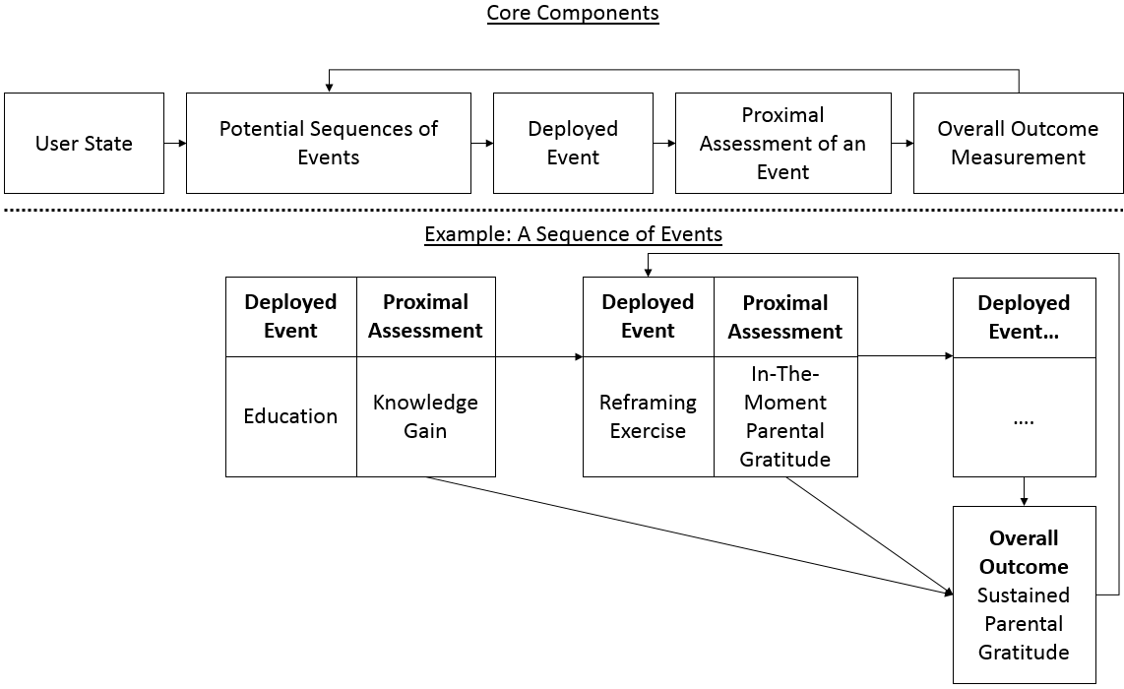

This notion of a digital micro-intervention as an effective sequence of events has conceptual overlap with Embry and Bilgan’s notion of evidence-based kernels [38]. In their definition kernels are influential elements, which constitute “fundamental units of behavior influence in the sense that deleting any component of a kernel would render it inert”. Similarly, the right combination of events is responsible for producing the digital micro-intervention’s outcome. As such, both the proximal assessments of events and the general outcome of the micro-intervention can feed into decision rules to guide future events. Decision rules may also incorporate contextual elements including user’s state, environmental variables, or previously identified user characteristics to allow dynamic tailoring of the micro intervention’s content (e.g. [39,40]). For example, if parental gratitude is not sustained in individuals who do not achieve knowledge-gain before successful exercise events routine, then it might mean that for individuals who fail in the first event (knowledge gain), there is no need to continue with the planned sequence. Alternatively, it might be that some individuals do not require a gain in knowledge prior to effective exercise events and therefore identifying them earlier based on their prior characteristics would enable to offer alternative paths within the same micro-intervention. Indeed, contextual variables appear to be important predictors of the likelihood a person will respond to a prompt and engage with the intervention [41].
Assessments
Assessing a digital micro-intervention’s impact can be divided into assessing the overall outcome of the intervention and assessing the more proximal outcomes of deployed events. The overall outcome for digital micro-interventions can be quite varied, although it is important to differentiate between the intervention outcome and the overall clinical goals, which are likely not the same. A digital micro-intervention for individuals with serious mental illness, for example, might focus on medication adherence [42] in the hopes of reducing clinical symptoms. In this case, each event included within the intervention would focus on steps and proximal outcomes related to medication adherence. For example, supporting reasons for taking medication might correspond to the proximal outcome of increasing motivation, and providing tailored reminders as to dosing periods or schedules might correspond to the proximal outcome of decreasing the cognitive effort needed to remember to initiate the desired activity. Assessing the overall benefit of this digital micro-intervention, therefore, should focus not on how the intervention results in an overall clinical goal, e.g. reduced symptoms of serious mental illness, but rather on how it impacted medication adherence. Importantly, if we examine the impact of events, we can explore how much each event contributes to the proximal outcome as well as the overall digital micro-intervention goal.
Another aspect that relates to assessments is the user’s engagement with the micro-intervention. In digital micro-interventions user engagement can be documented continuously based on program usage and experience of engagement (i.e. measuring the quality of attention, involvement, and immersion during program usage; for a review see [43-46]). These data could be key in identifying not only those who properly engage with the intervention, but also those who disengage without getting all they need from it, in order to feed intervention decision-rules to re-engage the users.
In this section we have defined a digital micro-intervention and presented its component parts. Next we address aspects that relate to the provision of digital micro-intervention care. These aspects require us to take into consideration principles guiding the use of digital micro-interventions as building blocks of a larger therapeutic process.

Digital Micro-Intervention Care: Digital Micro-Interventions as Building Blocks of a Larger Therapeutic Process
As described above, typically, single micro-interventions have relatively specific targets, rather than being full standalone treatments. Therefore, when developers think of a digital micro-intervention within a larger therapeutic process, they have to determine what makes the intervention relevant or helpful, which additional digital micro-interventions are expected or may be required over time, and how to integrate between the separate interventions within one therapeutic framework. In this section we aim to address principles that support such a successful integration.
A Conceptual Model to Guide Which Digital Micro-Interventions are Required and in What Context
In order to identify the relevant digital micro-interventions and the context in which they should be used, developers need a conceptual model of the therapeutic process, and how digital micro-interventions can address steps within this process. As an illustration consider the example of providing different digital micro-interventions within a long process of helping parents develop emotional and social competences in their child. In order to identify the required interventions, it is first necessary to build a rationale as to how these competences develop, maintained, and what issues should be prioritized. Table 3 presents such an example. The table is based on social-learning and behavioral theories (e.g. [47,48]) – building on concepts such as the parenting pyramid offered in the Incredible Years program [49], and parental monitoring and prevention of child behavior problems [47]. According to the model portrayed in the table there are levels of parenting behaviors – setting prioritization between basic vs. more advanced behaviors – and benefits for the child that occur when parents exercise these behaviors. The desired parenting behaviors are then used to identify the relevant digital micro-interventions for each level (see examples in Table 3).
The prioritization portrayed in the levels also presents the context in which each intervention is mostly relevant. If a digital micro-intervention care developer builds on this specific conceptualization, it would not make sense from their view to train parents to set clear limits before they are, for example, present in their children’s life. As such, the incorporation of a model helps developers avoid from designing and presenting people with a specific micro-intervention that is not contextually relevant with the larger perspective in mind.
Table 3. An example for a model defining the capabilities parents are required to present in order to prevent behavior problems and promote social and emotional competence.
Priority Level | Goal | Parent Behavior | Examples for Relevant Digital Micro-Interventions | Child Gains
First Level | Parental Availability | Presence; Attention; Monitoring | Notifying the parents put their smartphone away when doing activities with their child; Triggering to leave the child a positive note on the kitchen table to increase presence during working days. | Attachment; Self-esteem; Cooperation
 | Positive Parenting Practices | Positive involvement; Positive-modelling; Conversations; Play | Teaching how to play with a four year-old-child through scenario based learning.
Second Level | Problem Solving / Prevention | Social-coaching; Proactive identification of relevant guidelines; Consultations | Brief-online-video-guidance on how to coach a three year-old child during play on using their mouth instead of their hands. | Social skills; Meeting their potential; Motivation; Accountability
Third Level | Dealing with acute negative symptoms | Neglecting unhelpful routines and parenting styles; Embracing beneficial practices | Connecting the parent with a peer through an online community in order to find the right consequence for a child’s misbehavior. | Back to normative developmental cycle; Illness prevention

Nurturing a Therapeutic Narrative to Link Between Independent Interventions
The literature suggests the importance of a clear therapeutic pathway and rationale to the user’s therapeutic process and that relatability factors embedded within a digital intervention support a working alliance [50-53]. A theme can serve as a linking-bridge enabling to move from one digital micro-intervention to another in a way that consolidates between the different interventions. It is also essential because the right narrative would make the intervention more contextually relevant to the specific process the consumer is going through. For example, a parent who learned and conducted a gratitude exercise with the family around the dinner table may benefit if it were connected to the theme of overcoming child’s noncompliance – when this digital micro-intervention is part of a general aim of treating child’s disruptive behaviors. A different narrative may be in place for the same gratitude invoking intervention, when the larger goal is different – for example, increasing parenting satisfaction among veterans with post-traumatic-stress-disorder [54,55]. Another simple example would be a digital micro-intervention teaching individuals to change or reframe negative and unhelpful thoughts, that could be used for a broad range of clinical problems (e.g. [56-58]). Naturally, the binding therapeutic narrative between different digital micro-interventions would be different based on the targeted clinical problem.
Because the general process is the result of several digital micro-interventions combined together a therapeutic narrative may also have an important advantage as a moderator of the connection between each single intervention and sense of ownership and commitment towards the general process (see Figure 2 for a suggested illustration). This sense of ownership and commitment may, in turn, lead to beneficial outcomes such as increase in motivation to invest in subsequent digital micro-interventions in the same domain.
Figure 2. Nurturing a therapeutic narrative as a moderator to the connection between
the digital micro-intervention and sense of ownership and commitment to the therapeutic process.
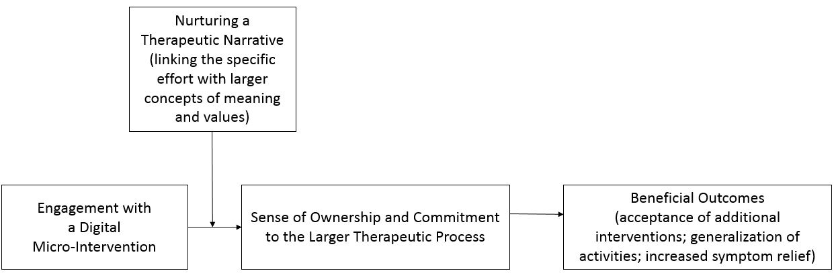

One Hub to Enable Proper Digital Micro-Intervention Care
The settings of multiple digital micro-interventions within one therapeutic process requires a hub component, in order to centralize and link between the separate interventions based on the principles discussed above. The hub is aimed at instilling a sense of accountability in the client [59] and at creating an integrated experience that relates to the therapeutic process while taking an individual's history into account. The hub meets these aims by: (a) recognizing individual’s state and context, (b) recommending on interventions that are relevant, and (c) help creating and maintaining the right narrative, meaning, and values that derive from each intervention and linking it to the larger therapeutic process.
The hub functions could be performed by any entity that is set to meet these aims – a digital application, a human technology coach, a consumer who self-manage his or her state, or a psychotherapist. For example, in their study of IntelliCare suite of apps aimed at treating depression and anxiety, Mohr and colleagues used a digital app as a hub that consolidated recommendations for the use of new apps [60]. Recommendations were based on user’s current usage data of different apps within the Intellicare suite to identify apps that the person will most likely use and find useful. Eventually, 95% of participants downloaded five or more of IntelliCare apps as part of their therapeutic process, demonstrating both the technical feasibility and acceptability of this approach [60]. In another study, health technology coaches met occasionally with patients diagnosed with schizophrenia, and suggested different digital tools based on individuals’ rehabilitation state, needs, and the impact of the tools they were using over time [61]. We could eventually see a new form of care, where a clinician (e.g., a psychotherapist, psychiatrist) acts as a facilitator, and meets with patients to suggest personalized digital micro interventions – including apps and online community supports.
Figure 3 presents a visualization of the relationship between the core components of digital micro-intervention care and aims to represent how the facilitator (digital app, health technology coach, clinician, etc.) integrates different interventions to curate one whole therapeutic process. The key components are:
- The conceptual model: Defines which digital micro-interventions are required, the relevant therapeutic narratives that links between different interventions, and the need states which also determine the evaluation scheme.
- Digital micro-intervention planner/identifier: Encompasses the process of identifying the relevant interventions that are currently available, and planning new interventions. The required interventions are defined based on the targeted need-states determined within the conceptual model (see Table 3 for an example).
- Digital micro-interventions suite: Includes all the potential interventions that are available. Once a need state is identified the relevant intervention will be offered to the individual.
- Timely evaluation of an individual's state: The evaluation scheme is based on data that relates to the individual (e.g., symptoms, demographics), context (e.g. changes in the environment that may change individual’s needs), and details about past interventions and their outcomes. Need states can be alerted in two different ways. First, predefined rules can be made to trigger an evaluation based on fixed times (e.g. every 3 months) or context (e.g. on a weekend when an individual is presumed to be more free or weekday when an individual is presumed to be working). Second, an individual can decide to report on their condition or needs they have encountered which will activate an evaluation.
- Intervention-phase: The intervention phase is based on two different components. The basic component is the digital micro-intervention itself. The second component represents the therapeutic narrative. The later involves (a) explaining the rationale for recommending the current micro-intervention to the consumer, (b) how it relates to the general therapeutic process (if relevant based on the conceptual model), (c) integrating the current and past experiences (e.g. success/failure in a previous intervention), and (d) relating to the future (e.g. at the end of the intervention - what is going to happen next and why) in relevant cases. (Appendix A presents an example for an automated therapeutic narrative that could be formed based on these subject matters.)
- Intervention documentation: Summary data that relates to engagement and outcomes is documented and used to feed the timely evaluation of individual’s state. For example, if an individual disengages from an intervention without a clear change in symptoms and context, a different micro-intervention can be offered.

Figure 3. Visualization of the relationship between core components of digital micro-intervention care.
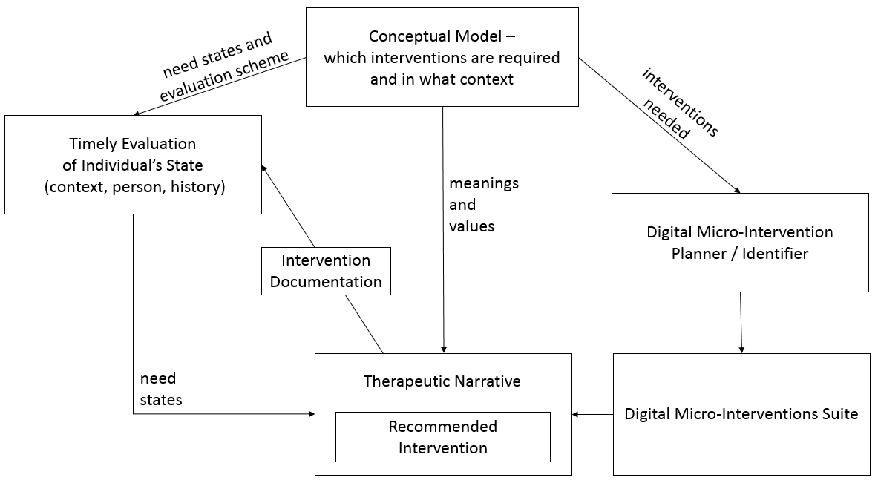

Ongoing Optimization
The success of the therapeutic process is limited by each of the units (micro-interventions) within it and the ways they are linked and interact with each other. An iterative approach may enable to identify those interventions that are missing or less effective, or a need to refine the conceptual model, for an ongoing development of the interventions’ ecosystem. This paper focus is not on the methodological aspects of intervention optimization strategies; however, we refer the reader to the Multiphase Optimization Strategy as a good example for a methodological framework aimed at intervention optimization [62]. We find this framework to be relevant to digital micro-intervention optimization because it is aimed at identifying the core sequence of elements that are efficacious, while providing a feasible method to account for potential intervening variables.
Figure 4 presents the different areas of evaluation that could be expected in order to build on past knowledge to optimize the system-of-care based on several levels of examination. The first level of optimization focuses on a specific digital micro-intervention. The receptivity and impact of the intervention is measured by user engagement, proximal events, and long-term outcomes. These results lead to optimization of intervention’s quality, and may raise subsequent questions about intervention’s impact that will require to add additional or alternative events or assessments. A subsequent evaluation regards the identification of specific populations and past experiences for whom/which the intervention was more or less successful (an interaction effect). The second level of optimization refers to interventions’ sequence. Similar to the interaction effect examined in one digital micro-intervention’s context, it regards identifying the best sequence of interventions which may differ based on client’s context. The third and last level refers to the therapeutic process. It aims at understanding whether there are new need states that are not yet covered within the system, whether the clinical target is achieved, and in which cases. For example, if there are individuals who are properly engaged with the recommended sequence of micro-interventions, however do not reach the clinical target; or individuals not engaged with any micro-interventions that were offered. This will lead to optimizing the intervention planning, characterizing user population for whom this system-of-care is relevant, and to the development of new interventions. The conceptual model is relevant in all levels of optimization, because developers’ understanding of what works and for whom enables to refine the model itself, which is then used to optimize the interventions and their sequence.

Figure 4. Levels of optimization.

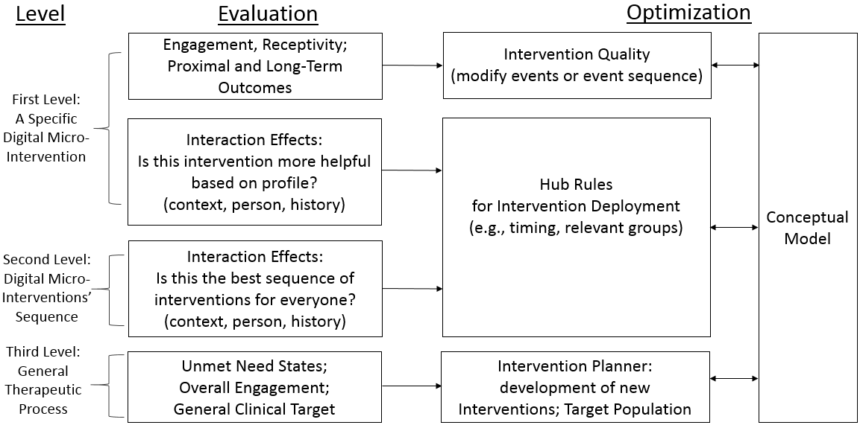

Example: Digital Micro-Intervention Care Versus a Stepped-Care Approach
In this final section of the paper, we compare the concept of digital micro-intervention care to a stepped-care approach. Stepped care is a common conceptualization that combines a set of interventions within one therapeutic process [63-65]. A stepped care approach is defined by two main principles. First, the least intensive/restrictive treatment that is expected to provide the desired health gain is offered to the patient. Second, the model is adaptive in the sense that those individuals who do not reach a desired health gain in a predetermined time-period, will be assigned to a more intensive/restrictive treatment option. Therefore, a stepped-care approach is based on treatments designed to reach the desired health target, where these treatments differ in intensity. In contrast, a single digital micro-intervention is not expected to support a full therapeutic target (e.g. overcoming depression) but rather be a step along the way. This is reasonable given that when conceptualizing the use of multiple digital micro-interventions, we do not assume that people are willing to invest as much effort as ideally needed to complete a whole target of therapeutic process.
Figure 5 presents illustrations of the two frameworks, based on these underlying differences in delivery of care. In comparison to a stepped-care model, in digital micro-intervention care:
- Each intervention unit is highly focused and is generally short, reducing the effort needed for completion.
- The setting of care does not prioritize intervention sequence based on treatment intensity but rather based on a complex understanding of people’s needs and preferences (as described in the conceptual model section). Therefore, we do not see a graded intervention sequence in terms of intensity.
- The therapeutic sequence does not focus on a given time-window in which an intervention occurs continuously until completion, as it would be expected in traditional models of proactive treatment delivery. This means that the therapeutic sequence may be very long and that individuals are sometimes engaged and sometimes not engaged with any intervention. In some cases, people do not receive any intervention most of the time. Maintaining an ongoing contact with users may be required to allow triggering the right intervention at the right time.
- There might be a large number of different digital micro-interventions to achieve the target of the treatment process, in comparison to stepped care models which are mostly based on few interventions (although each standard-intervention include multiple components).

Figure 5. Illustrations of stepped-care and digital micro-intervention care models.
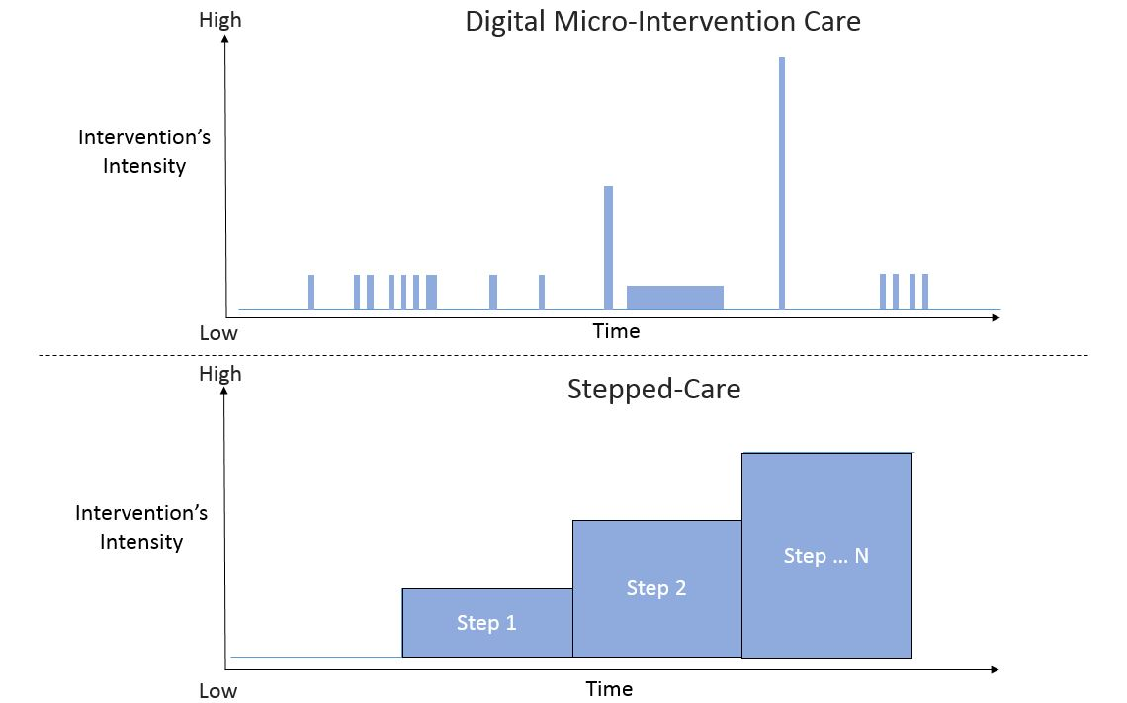

Conclusions
Digital micro-interventions may provide new ways to deliver behavioral and mental health interventions while meeting people’s capacity to invest small effort in beneficial therapeutics. The development of digital micro-interventions, however, demands new thinking. We cannot merely take previous interventions based on other models and assume they will have the focused and immediate impacts required of micro-interventions. As such, we have proposed a novel model of understanding digital micro-interventions by identifying their component parts (events), how these parts work together (decision rules), and how digital micro-interventions might be incorporated into a larger therapeutic process. This model is helpful to assist researchers in optimizing digital micro-interventions, developing the conceptual understanding of each intervention’s role within a larger process, and leaning on principles to best integrate between these interventions over time.
It is worth noting, however, that multiple issues related to digital micro-interventions still need to be resolved. First, research methodologies that can facilitate the evaluation of micro-interventions are required. Micro-randomized trials are one such methodology that could be of use here, especially when research questions are related to dynamic processes of change over time [66]. Second, methods for optimizing digital micro-interventions and improving micro-intervention suites needs to be explored. Third, we need to understand the people and targets for which the delivery of digital micro-intervention care is more or less suitable.
Much of the current innovation in micro-interventions has made use of technological affordances as technology makes it more feasible to deliver digital micro-interventions in various ways. However, again, it does not necessarily mean that this sort of intervention has to be digital by nature. Because technology is highly embedded in our lives it is possible that digital capabilities such as automated monitoring, triggering, and instant messaging tools will be commonly integrated into care making the differentiation between digital and non-digital tools to be less relevant.
Expanding the portfolio of behavioral and mental health interventions to include interventions that allow people to interact in various modalities, intensities, and styles is likely necessary to make such interventions available to vast number of people who could stand to benefit from them. Digital micro-interventions represent one such example of such an expansion as they are brief, focused, and potentially more appropriate for people who enter with various levels of motivation. We hope the model represented here will structure and speed the work in this area and improve the research and delivery of digital micro-intervention care.
Conflict of interest: The authors declare no conflict of interest

References

1. World Health Organization. The World Health Report 2001 - Mental health: new understanding, new hope. Geneva: World Health Organization; 2001.
2. World Health Organization. Neuroscience of psychoactive substance use and dependence. Geneva: World Health Organization; 2004.
3. Demyttenaere K, Bruffaerts R, Posada-Villa J, Gasquet I, Kovess V, Lepine J, Angermeyer M, Bernert S, De Girolamo G, Morosini P. Prevalence, severity, and unmet need for treatment of mental disorders in the World Health Organization World Mental Health Surveys. JAMA. 2004;291(21):2581-2590.
4. Kessler RC, Berglund PA, Bruce ML, Koch JR, Laska EM, Leaf PJ, Manderscheid RW, Rosenheck RA, Walters EE, Wang PS. The prevalence and correlates of untreated serious mental illness. Health Serv Res. 2001;36(6/1):987-1007.
5. Kane JM, Robinson DG, Schooler NR, Mueser KT, Penn DL, Rosenheck RA, Addington J, Brunette MF, Correll CU, Estroff SE. Comprehensive versus usual community care for first-episode psychosis: 2-year outcomes from the NIMH RAISE Early Treatment Program. Am J Psychiatry. 2015;173(4):362-372.
6. Wang PS, Berglund P, Olfson M, Pincus HA, Wells KB, Kessler RC. Failure and delay in initial treatment contact after first onset of mental disorders in the National Comorbidity Survey Replication. Arch Gen Psychiatry. 2005;62(6):603-613.
7. Clement S, Brohan E, Jeffery D, Henderson C, Hatch SL, Thornicroft G. Development and psychometric properties the Barriers to Access to Care Evaluation scale (BACE) related to people with mental ill health. BMC Psychiatry. 2012;12(1):36.
8. Mohr DC, Ho J, Duffecy J, Baron KG, Lehman KA, Jin L, Reifler D. Perceived barriers to psychological treatments and their relationship to depression. J Clin Psychol. 2010;66(4):394-409.
9. Mohr DC, Hart SL, Howard I, Julian L, Vella L, Catledge C, Feldman MD. Barriers to psychotherapy among depressed and nondepressed primary care patients. Ann Behav Med. 2006;32(3):254-258.
10. Kazdin AE. Addressing the treatment gap: A key challenge for extending evidence-based psychosocial interventions. Behav Res Ther. 2017;88:7-18.
11. Ogrodniczuk JS, Kealy D, Laverdière O, Joyce AS. So, who wants to be here? A survey of patients’ motives for seeking psychotherapy services and their expected un-involvement in therapy. Archives of Psychiatry and Psychotherapy. 2018;3:26-30.
12. Baumel A, Muench F, Edan S, Kane JM. Objective user engagement with mental health apps: Systematic search and panel-based usage analysis. J Med Internet Res. 2019;21(9):e14567.
13. Fleming T, Bavin L, Lucassen M, Stasiak K, Hopkins S, Merry S. Beyond the Trial: Systematic Review of Real-World Uptake and Engagement With Digital Self-Help Interventions for Depression, Low Mood, or Anxiety. J Med Internet Res. 2018;20(6):e199.
14. Baumel A, Edan S, Kane JM. Is there a trial bias impacting user engagement with unguided e-mental health interventions? A systematic comparison of published reports and real-world usage of the same programs. Transl Behav Med. 2019;9(6):1020-1033.
15. Fernando LMN, Sim WH, Jorm AF, Rapee R, Lawrence KA, Yap MB. Parenting Resilient Kids (PaRK), an online parenting program to prevent anxiety and depression problems in primary school-aged children: study protocol for a randomised controlled trial. Trials. 2018;19(1):236.
16. Norcross JC, Wampold BE. What works for whom: Tailoring psychotherapy to the person. J Clin Psychol. 2011;67(2):127-132.
17. Andrews G, Williams AD. Internet psychotherapy and the future of personalized treatment. Depress Anxiety. 2014;31(11):912-915.
18. Baumel A, Kane JM. Examining predictors of real-world user engagement with self-guided eHealth interventions: Analysis of mobile apps and websites using a novel dataset. J Med Internet Res. 2018;20(12):e11491.
19. Baumel A, Yom-Tov E. Predicting user adherence to behavioral eHealth interventions in the real world: Examining which aspects of intervention design matter most. Transl Behav Med. 2018;5(5):793-798.
20. Fogg BJ. A behavior model for persuasive design. Paper presented at: Proceedings of the 4th international Conference on Persuasive Technology.2009; California, USA.
21. Kelders SM, Kok RN, Ossebaard HC, Van Gemert-Pijnen JE. Persuasive system design does matter: A systematic review of adherence to web-based interventions. J Med Internet Res. 2012;14(6):e152. PMID:23151820.
22. Fuller-Tyszkiewicz M, Richardson B, Lewis V, Linardon J, Mills J, Juknaitis K, Lewis C, Coulson K, O'Donnell R, Arulkadacham L. A randomized trial exploring mindfulness and gratitude exercises as eHealth-based micro-interventions for improving body satisfaction. Comput Human Behav. 2019;95:58-65.
23. Meinlschmidt G, Lee J-H, Stalujanis E, Belardi A, Oh M, Jung EK, Kim H-C, Alfano J, Yoo S-S, Tegethoff M. Smartphone-based psychotherapeutic micro-interventions to improve mood in a real-world setting. Front Psychol. 2016;7:1112.
24. Kakihara M. Grasping a global view of Smartphone diffusion: An analysis from a global Smartphone study. Paper presented at: ICMB2014.
25. Mobile Fact Sheet. http://www.pewinternet.org/fact-sheet/mobile/. Accessed January 7, 2019. Archived by WebCite® at http://www.webcitation.org/75F2i2NKz. 2019.
26. Bezerra J, Bock W, Candelon F, Chai S, Choi E, Corwin J, DiGrande S, Gulshan R, Michael D, Varas A. The mobile revolution: How mobile technologies drive a trillion-dollar impact. Boston, MA: Boston Consulting Group. 2015.
27. Rainie L. Internet, broadband, and cell phone statistics. Pew Internet & American Life Project. 2010;5:479-530.
28. Hopko DR, Armento ME, Robertson S, Ryba MM, Carvalho JP, Colman LK, Mullane C, Gawrysiak M, Bell JL, McNulty JK. Brief behavioral activation and problem-solving therapy for depressed breast cancer patients: Randomized trial. J Consult Clin Psychol. 2011;79(6):834-849.
29. Coolican J, Smith IM, Bryson SE. Brief parent training in pivotal response treatment for preschoolers with autism. Journal of Child Psychology and Psychiatry. 2010;51(12):1321-1330.
30. Hetrick SE, Cox GR, Witt KG, Bir JJ, Merry SN. Cognitive behavioural therapy (CBT), third‐wave CBT and interpersonal therapy (IPT) based interventions for preventing depression in children and adolescents. Cochrane Database of Systematic Reviews. 2016(8).
31. Ayers S, Fitzgerald G, Thompson S. Brief online self-help exercises for postnatal women to improve mood: A pilot study. Maternal and Child Health Journal. 2015;19(11):2375-2383.
32. Strauman TJ, Socolar Y, Kwapil L, Cornwell JF, Franks B, Sehnert S, Higgins ET. Microinterventions targeting regulatory focus and regulatory fit selectively reduce dysphoric and anxious mood. Behav Res Ther. 2015;72:18-29.
33. Elefant AB, Contreras O, Muñoz RF, Bunge EL, Leykin Y. Microinterventions produce immediate but not lasting benefits in mood and distress. Internet Interventions. 2017;10:17-22.
34. Pellegrini CA, Hoffman SA, Daly ER, Murillo M, Iakovlev G, Spring B. Acceptability of smartphone technology to interrupt sedentary time in adults with diabetes. Transl Behav Med. 2015;5(3):307-314.
35. Heron KE, Smyth JM. Ecological momentary interventions: incorporating mobile technology into psychosocial and health behaviour treatments. Br J Health Psychol. 2010;15(1):1-39.
36. Schueller SM, Aguilera A, Mohr DC. Ecological momentary interventions for depression and anxiety. Depress Anxiety. 2017;34(6):540-545.
37. Nahum-Shani I, Smith SN, Spring BJ, Collins LM, Witkiewitz K, Tewari A, Murphy SA. Just-in-time adaptive interventions (JITAIs) in mobile health: Key components and design principles for ongoing health behavior support. Ann Behav Med. 2018;52(6):446-462.
38. Embry DD, Biglan A. Evidence-based kernels: Fundamental units of behavioral influence. Clin Child Fam Psychol Rev. 2008;11(3):75-113.
39. Graham AL, Papandonatos GD, Jacobs MA, Amato MS, Cha S, Cohn AM, Abroms LC, Whittaker R. Optimizing text messages to promote engagement with Internet smoking cessation treatment: Results from a factorial screening experiment. J Med Internet Res. 2020;22(4):e17734.
40. Muench F, van Stolk-Cooke K, Kuerbis A, Stadler G, Baumel A, Shao S, McKay JR, Morgenstern J. A randomized controlled pilot trial of different mobile messaging interventions for problem drinking compared to weekly drink tracking. PLoS One. 2017;12(2):e0167900.
41. Bidargaddi N, Almirall D, Murphy S, Nahum-Shani I, Kovalcik M, Pituch T, Maaieh H, Strecher V. To prompt or not to prompt? A microrandomized trial of time-varying push notifications to increase proximal engagement with a mobile health app. JMIR Mhealth Uhealth. 2018;6(11):e10123.
42. Nieuwlaat R, Wilczynski N, Navarro T, Hobson N, Jeffery R, Keepanasseril A, Agoritsas T, Mistry N, Iorio A, Jack S. Interventions for enhancing medication adherence. Cochrane Database of Systematic Reviews. 2014(11).
43. Glas N, Pelachaud C. Definitions of engagement in human-agent interaction. Paper presented at: 2015 International Conference on Affective Computing and Intelligent Interaction (ACII)2015; Xi’an, China.
44. Perski O, Blandford A, West R, Michie S. Conceptualising engagement with digital behaviour change interventions: A systematic review using principles from critical interpretive synthesis. Transl Behav Med. 2016;7(2):254-267.
45. Perski O, Blandford A, Garnett C, Crane D, West R, Michie S. A self-report measure of engagement with digital behavior change interventions (DBCIs): Development and psychometric evaluation of the “DBCI Engagement Scale”. Transl Behav Med. 2020;10(1):267-277.
46. Yeager CM, Benight CC. If we build it, will they come? Issues of engagement with digital health interventions for trauma recovery. Mhealth. 2018;4(37).
47. Dishion TJ, McMahon RJ. Parental monitoring and the prevention of child and adolescent problem behavior: A conceptual and empirical formulation. Clin Child Fam Psychol Rev. 1998;1(1):61-75.
48. Sanders MR. Triple P-Positive Parenting Program: Towards an empirically validated multilevel parenting and family support strategy for the prevention of behavior and emotional problems in children. Clin Child Fam Psychol Rev. 1999;2(2):71-90.
49. Borden LA, Schultz TR, Herman KC, Brooks CM. The Incredible Years Parent Training Program: Promoting resilience through evidence-based prevention groups. Group Dyn. 2010;14(3):230.
50. Cavanagh K, Millings A. (Inter) personal computing: The role of the therapeutic relationship in e-mental health. J Contemp Psychother. 2013;43(4):197-206.
51. Holter MT, Johansen A, Brendryen H. How a fully automated eHealth program simulates three therapeutic processes: A case study. J Med Internet Res. 2016;18(6):e176. PMID:27354373
52. Barazzone N, Cavanagh K, Richards DA. Computerized cognitive behavioural therapy and the therapeutic alliance: A qualitative enquiry. Br J Clin Psychol. 2012;51(4):396-417. PMID:23078210.
53. Baumel A, Birnbaum ML, Sucala M. A Systematic Review and Taxonomy of Published Quality Criteria Related to the Evaluation of User-Facing eHealth Programs. J Med Syst. 2017;41(8):128.
54. Cohen E, Zerach G, Solomon Z. The implication of combat-induced stress reaction, PTSD, and attachment in parenting among war veterans. J Fam Psychol. 2011;25(5):688-698.
55. Casselman RB, Pemberton JR. ACT-based parenting group for veterans with PTSD: Development and preliminary outcomes. The American Journal of Family Therapy. 2015;43(1):57-66.
56. Marks I, Lovell K, Noshirvani H, Livanou M, Thrasher S. Treatment of posttraumatic stress disorder by exposure and/or cognitive restructuring: A controlled study. Arch Gen Psychiatry. 1998;55(4):317-325.
57. Robson Jr JP, Troutman-Jordan M. A concept analysis of cognitive reframing. Journal of Theory Construction & Testing. 2014;18(2).
58. Vernooij‐Dassen M, Draskovic I, McCleery J, Downs M. Cognitive reframing for carers of people with dementia. Cochrane Database of Systematic Reviews. 2011(11).
59. Mohr DC, Cuijpers P, Lehman K. Supportive accountability: A model for providing human support to enhance adherence to eHealth interventions. J Med Internet Res. 2011;13(1):e30. PMID:21393123.
60. Mohr DC, Tomasino KN, Lattie EG, Palac HL, Kwasny MJ, Weingardt K, Karr CJ, Kaiser SM, Rossom RC, Bardsley LR, Caccamo L, Stiles-Shields C, Schueller SM. IntelliCare: An eclectic, skills-based app suite for the treatment of depression and anxiety. J Med Internet Res. 2017;19(1):e10. PMID:28057609.
61. Baumel A, Correll CU, Hauser M, Brunette M, Rotondi A, Ben-Zeev D, Gottlieb JD, Mueser KT, Achtyes ED, Schooler NR. Health technology intervention after hospitalization for schizophrenia: service utilization and user satisfaction. Psychiatr Serv. 2016;67(9):1035-1038.
62. Collins LM. Optimization of behavioral, biobehavioral, and biomedical interventions: The multiphase optimization strategy (MOST). Springer; 2018.
63. Bower P, Gilbody S. Stepped care in psychological therapies: access, effectiveness and efficiency: Narrative literature review. The British Journal of Psychiatry. 2005;186(1):11-17.
64. Haaga DA. Introduction to the special section on stepped care models in psychotherapy. J Consult Clin Psychol. 2000;68(4):547.
65. Sobell MB, Sobell LC. Stepped care as a heuristic approach to the treatment of alcohol problems. J Consult Clin Psychol. 2000;68(4):573-579.
66. Walton A, Nahum‐Shani I, Crosby L, Klasnja P, Murphy S. Optimizing digital integrated care via micro‐randomized trials. Clin Pharmacol Ther. 2018;104(1):53-58.

Appendix A – An example for an automated therapeutic narrative
In the following example, we present an automated therapeutic narrative that is based on a pre-written text. The narrative is presented to a parent who is enrolled to digital micro-intervention care that targets positive parenting practices. In this example, the therapeutic narrative and recommended intervention follows a parent report on child’s misbehaviors after successful completions of two micro-interventions that are based on Table 3 levels of prioritization (first level: improving quality time through play; second level: social coaching). Content within “[]” represent values situated within a predetermined variable.
“Hi [parent_name], thank you for entering the program and reporting on [child_name]’s misbehaviors. We analyzed your data and notice your success in prior micro-interventions that focused on [incorporating positive interaction routines (e.g. quality time with); problem solving (e.g. helping your child doing homework)].
Your effort invested in prior steps helped you build a better relationship with your child, as part of your commitment to improve your parenting skills.
This now enables you to focus on directly coping with [child_name]’s noncompliance to your requests. Congratulations for keep making the conscious choice of investing effort in improving your parental skills! These skills are so crucial in helping [child_name] get by with his family, teachers, and friends. Here is a link to your new step: [URL]”

